|  |  |
| --- | --- |
| iNCLUDING MACROECONOMIC EFFECTS WHEN ANALZING REGULATIONS TOWARDS THE DANISH INCOME INSURANCE PROGRAM  Performing a counterfactual analysis in a Stock-Flow-Consistent framework | Abstract  *This paper attempts to evaluate the decision to suppress the state regulation percentage, starting from 2016, voted through by the Danish government in the tax reform of 2012. We do so by estimating the macro elasticity of income insurance on unemployment. We use the income insurance model build to analyze changes to the Danish income insurance program, as a proxy for the micro elasticity. To additionally get the macroeconomic effects we set up a counterfactual analysis, removing the suppressing of the state regulation percentage in a stock-flow-consistent model. We use the quarterly model for the Danish economy developed by Mikal et al. (2022) incorporating the Danish income insurance program and five macroeconomic channels for this to affect the economy. We simulate the model including these channels to generate an estimate of the change in unemployment associated with each channel both independently and together. Having found both the macro and micro effects we estimate the macro elasticity to be approximately twice as large as the micro elasticity in the case of Denmark. This Indicates that suppressing the state regulation percentage in Denmark was a correct decision looking at the economic welfare. More interestingly, we find this conclusion to be highly dependent on two findings. First, whether the Danish economy is categorized as wage-led or profit-led. Second, the willingness of the worker unions to maintain a high incentive to work, by maintaining a minimum-gap between the level of income insurance and wages. The results of this paper questions the way in which only microeconomic effects so far has been considered when evaluating political decisions regarding the Danish income insurance program.*  Simon Fløj Thomsen  9. Semester student |

Education: Oecon   
Semester: 9  
Group: 1  
Name: Simon Fløj Thomsen   
Superviser: Mikael Byrialsen

Word Count: 19954

# Section 1: Introduction

The Danish Flexicurity model is well known worldwide, for being one of the most effective in keeping a low and stable unemployment rate compared to the other European countries. Looking at the unemployment rate leading up to the financial crisis in 2008, Denmark had one of the lowest rates out of all the European countries. Andersen & Svarer (2006) present three elements of the Danish flexicurity model contributing to the low unemployment rate. The first element being flexibility in the form of low hiring terms as well as short termination periods. The second element being security in the form of generous unemployment benefits, and the third element being an active labor market policy.  
The flexible hiring and termination terms ensure that Danish companies can adjust their workforce according to changes in production, without major costs. The worker unions allow these flexibilities for the firms because of the high level of unemployment benefits ensuring that individuals will not risk a major reduction in income if being laid off. For unemployed to receive these benefits it is required that they take part in activities improving their human capital, while they at the same time actively search for a new job.

As presented by Kongshøj (2015), the flexicurity model of Denmark has been under pressure in the later years, some attribute this to the falling compensation rate showing how the growth in the level of income insurance has been lower than the growth of the average wages. One of the more recent regulations on this area is the political decision, implemented in the Danish tax reform 2012, to suppress the regulations of unemployment benefits in the period of 2016-2023. Starting from 2016, there has been a deduction in the growth of the maximum level of income insurance a person can receive based on the worker’s wage. Usually, the growth is determined so that it approximately follows the growth in wages, but in 2016 additionally 0.3 percent points were subtracted of the growth rate in the maximum level of income insurance. In 2017 0.4 percent points were subtracted, and in the period of 2018-2023 0.75 percent points were subtracted. (Danish Ministry of Taxation, 2012)

This paper attempts to evaluate the political decision to suppress the regulation of the maximum level of income insurance. In contrast to the model used by the Danish government to analyze changes to the Danish income insurance program (IS-program), we include both macro and micro- economic effects in our analysis. Thereby, we are obtaining a more adequate evaluation of the political decision.   
We use a stock-flow consistent model as this first of all enables us to isolate the effect of the suppressing of the regulations in a counter factual scenario, thereby not letting other factors influence our results. Also, it enables us to include the effects of changes in stocks, as well as including the feedback effects when assessing the effects over time. To the best of our knowledge, we are the first to use a SFC framework to obtain the elasticity of the macroeconomic effects of changes to the level of income insurance on unemployment. Former studies trying to analyze these macroeconomic effects, have used boarder-based approaches, this has led to mixed results possibly due to biased estimates based on violations of the assumptions required for these methods. A Stock-Flow consistent model will overcome these biases, and by comparing our results of the macroeconomic effects with the results of a micro founded model in the form of the Danish income insurance model (IS-model), we get an idea of the relationship between the micro and macro elasticity of income insurance on unemployment. This allows us to discuss how taking into account the macroeconomic effect when evaluating the political initiative made in 2012 changes the conclusion when looking at the economic welfare.

This paper makes three important contributions. First, we build upon the empirical SFC-model presented by Byrialsen et al. (2022) integrating the dynamics of the Danish income insurance program, specifically including the variables that are used for political regulation of the unemployment benefits. Second, we perform a counterfactual analysis by removing the regulation made towards the unemployment benefits in the tax reform of 2012, making it possible to evaluate this regulation. Third, this paper contributes to the more recent focus on the aggregate effects of changes in the level of income insurance, looking at the relationship between the micro and macro effects of changes in income insurance.

The paper is organized as follows: Section 1 presented a short introduction of the Danish income insurance program, including a description of the most recent regulation towards the growth of the maximum level of income insurance. Section 2 will present the current literature on the effects of changes to the IS-program, focusing on both the micro- and macro-effects. In section 3 we provide a further description of the Danish IS-program and take a closer look at the IS-model build in 2015 today used by the government to analyze political regulations towards the Danish IS-program. In section 4 we will present a quarterly SFC-model for Denmark, specifically looking at the Danish IS-program, analyzing different macroeconomic channels in the model. In section 6 we use the results from section 5 to obtain a relationship between the macro and micro elasticity of income insurance on unemployment and use these to discuss the welfare effects of completing the initiative from the tax reform of 2012. Lastly in section 6 we conclude the results.

# Section 2: Literature review

In the later years there has been a large amount of literature towards the effects of unemployment benefits. Mostly focusing on the link between the compensation rate and employment. A large part of the literature investigating the incentive to work and job-search, has been reviewed by Andersen et al. (2015) they find that the majority of the literature show evidence for a higher movement from unemployment to employment when reducing the unemployment benefits, thereby increasing the exit-rate from unemployment. The two main effects associated with the exit-rate are the Moral Hazard and Liquidity effect, both build on a micro foundation. Chetty (2008) finds that the liquidity effects explain 60% of the effect on the unemployment period when changing the level of income insurance. In contrast to these effects, where income is the only factor when looking at incentives to switch between employment and unemployment, Howell & Azizoglu (2011) provide another link as they find a positive relationship between working and happiness, independently of income insurance, thereby questioning the often-argued positive relationship between working and disutility.

Andersen et al. (2015) also address the approach effect using a micro foundation it shows that a relationship should exist between the movement from employment to unemployment and the level of income insurance, they add that at the given time the literature towards the approach rate is still sparse, not showing any significant movement when changing the level of income insurance. Besides the effects presented by Andersen et al. (2015), one new study is presented by The Economic council of Denmark (DØRS) (2022), showing significant evidence for a lower job-search for people already in employment when income insurance increases (Gutierrez, 2016).

DØRS (2022) argue that the reason for the lack of new literature towards the approach rate is that newer literature is moving away from the narrow micro founded point of view of only looking at the effects on the behavior of unemployed and employed, which empirically would only result in the micro elasticity of income insurance on unemployment.

Instead, newer literature focuses on aggregated effects of changes in the unemployment benefits, and thereby estimate a macro elasticity for income insurance on unemployment. Fredriksson & Söderström (2020) looks at the aggregated effects of a reform in Sweden concluding that the number of unemployed increases by 3% when increasing the income insurance ceiling by 1%. They find that this macro elasticity is twice as large as the elasticity coming from the micro founded effects of changing behavior of unemployed. On the other hand, a study by Boone et al. (2021) finds that the aggregated effects are almost zero, but still points out the importance in finding the relationship between the micro and macro elasticity. As will be further discussed in section 5, the empirical evidence at this point seems inconclusive considering macroeconomic effects when evaluating political decisions towards unemployment benefits.

The very popular micro founded models makes it hard to analyze the macroeconomic effects found by Fredriksson & Söderström (2020), as the models are usually build using aggregated micro effects as the total macroeconomic effect. Also, these models imply a large focus on the supply side of the economy, thereby tending to ignore the effects of the demand side. Post-Keynesian theory seems to overcome these short comings making it more suitable for this type of analysis, by not building on the narrow micro founded effects. Post-Keynesian literature determines the employment and real wages by looking at effective demand, this implies that an increase in the aggregate demand will raise the level of economic activity, creating more jobs. Dray & Thirlwall (2011) mentions that demand can create its own supply within limits, therefore it makes little economic sense to see growth as supply constrained. This implies that we should focus on the income distribution determinants of aggregate demand, paying less attention to the supply-side factors.

In general, post-Keynesians have proposed redistributive policies, favoring an increase in social expenditures – including unemployment benefits – which are important for income distribution. Post-Keynesians take in regard both fairness, in the form of lower inequality, and the economic gain from favoring income distribution, the last depending on whether the policy is considered to be pro-labor or pro-capital. As described by Stockhammer & Lavoie (2013) pro-labor distributional policies are those increasing the wage-share whereas pro-capital distributional policies usually claim to promote ‘labor market flexibility’ or wage flexibility, rather than increasing capital income. Increases in the unemployment benefits are therefore seen as a pro-labor policy. If a pro-labor policy is found to expand the economy, it is called a wage-led regime, on the other hand if this contracts the economy it indicates a profit-led regime.

Looking at which macroeconomic channels that the literature suggest should play a role when analyzing the level of income insurance, the first channel follows the idea of post-Keynesian theory suggesting that a higher level of income insurance should lower the unemployment through a higher aggregate demand. The demand channel suggests that changes in level of income insurance affect the level of aggregated demand and thereby the demand for employment. Byrialsen & Raza (2018) include this channel when analyzing the macroeconomic effects of income insurance.

Another channel is introduced by Andersen et al. (2015) finding empirical evidence that unemployment benefits has a positive relationship with wages. It is argued that a change in the level of income insurance will affect the wage negotiations, expecting that a higher level of income insurance would increase the targeted wages demanded of the worker unions, who wants to maintain a high incentive to work. The effects of a higher wage given by Andersen et al. (2015) is mostly based on micro level explanations in which the wage will have a negative effect in the form of lowering the demand for labor increasing the number of unemployed. The channel in which the wage affects the unemployment is different in another study by Byrialsen & Raza (2018) arguing that wages will affect the wage-share of the economy and depending on whether the economy is wage-led or profit-led the unemployment will be positively or negatively affected (Stockhammer & Lavoie, 2013). They use the framework of a theoretical stock-flow consistent model, including the compensation rate in the wage equation, together with the rate of employment, and productivity. The inclusion of the compensation rate in a stock-flow-consistent framework is an addition to the model used by Lavoie & Godley (2012). Byrialsen & Raza (2018) argues that incorporating the compensation rate is in line with standard models of wage setting, which plays an important role in the determination of the targeted wage (Mcdonald & Solow, 1981; Shapiro & Stiglitz, 1984).

Statistics Denmark (2012) also includes a link between the compensation rate and the wages, the link goes through the structural unemployment, which is positively affected by the compensation rate, meaning an increase in the compensation rate increases the structural unemployment. In the wage equation the difference between the unemployment and structural unemployment is affecting the wages in the next period negatively. This creates a situation where employment above the structural employment makes the wage negotiations harder for the workers and thereby negatively affects the wages.

A third macroeconomic effect is based on the previous discussion, whether we should use the liquidity or Moral Hazard effect, when explaining the effect on the exit-rate. Of these two, the most commonly used explanation is the Moral Hazard effect, where an increase in the level of income insurance will result in lower incentive to search for a new job, and in addition to this also be pickier regarding job offers increasing the unemployment period.   
Chetty (2008) instead presents the explanation of why an increase in the level of income insurance, through the liquidity effect, should affect the period in which people are unemployed, thereby lowering the exit-rate. He claims that unemployed are experiencing a budget constraint, as they are using their savings to keep a higher level of consumption. When one’s savings are running low (which will take longer the higher the level of income insurance), that person might be more likely to accept jobs that are not socially efficient. If the liquidity effect is present, when decreasing the level of income insurance, this could lead to a matching effect resulting in a worse job match between employer and employed, not taking advantage of the higher productivity the employer could have had in another job position with a better match. Chetty (2008) finds that the liquidity effect explains 60% of the effect on the unemployment period from an increase in the level of income insurance. Using this argumentation, we should expect a rise in the level of income insurance to have an aggregated effect on productivity.   
Andersen et al. (2015) looks at the empirical evidence found for the effect of liquidity constraints on the quality of a job-match. The effect can arise through heterogeneity for both companies and workers that matters for a job-match. It will take time and costs for both companies and workers to localize a good match. In Addition to this there will be a lock-in effect as there are associated costs of firing/quitting and finding a new employer/employed. This means that workers might not be in the job where they are maximizing their productivity, and reallocation of the working force could therefore lead to a higher output.   
Therefore, when increasing the level of income insurance, there will be a decrease in job search lowering the employment quantitively, but the quality might increase due to the above-mentioned effect. Andersen et al. (2015) presents two measures for the quality of the working force, the wage and hiring period[1]. The challenging part being to control for other effects, affecting the wage and hiring period.   
Andersen et al. (2015) presents several studies, all indicating that a more generous income insurance program results in an extended unemployment period, approximately half of the studies find positive effects on the match-quality, the other half find no effects, and one study finds significant negative effects. The majority of the studies only find evidence using changes in the income insurance period, and not the level of income insurance.   
A possible explanation for the weak empirical evidence is also presented by Andersen et al. (2015) who shows evidence for a reverse effect of income insurance on the productivity, they argue that as people are spending longer time unemployed, their human capital falls, lowering their productivity[2]. This may be capable of explaining the mixed empirical evidence for a channel existing between the level of income insurance and productivity.

Additionally to the matching effect, Millemaci & Ofria (2014) present the Verdoon-effect arguing that labor productivity usually is found to be procyclical. This effect is also used by Fazzari (2020), who use the unemployment rate as a regressor of productivity explaining that when there is higher economic activity, R&D expenditures also tends to rise, thereby increasing productivity.

A macroeconomic channel not getting that much attention in the literature, is the effect of income insurance on the participation rate. Fazzari et al. (2020) endogenizes the labor force using the strength of the economy measured by the unemployment rate as a regressor. He argues that the unemployment rate should have a negative relationship with the labor force. The main reason is that a decline in labor force participation should imply a rising difficulty of finding an acceptable job match as unemployment rises, additionally evidence suggests that higher unemployment also tends to reduce immigration, thereby affecting the labor force (Setterfield, 2003).

Lastly, as the income insurance program is not mandatory in Denmark, it is argued that one should expect a lower compensation rate to affect the insurance rate (The rate of workers being a member of the income insurance program) (Aastrup, 2018; Jensen, 2021; Risgaard, 2021)[3]. Interestingly it is found that in the same period as the fall in the compensation rate, the percentage of the working force being a member of the income insurance program has dropped from 84% till 78% even though this period has included political adjustment intended to raise this percentage (Risgaard, 2021). Aastrup (2018) includes several channels in which a higher insurance rate affects the economy, most importantly, he argues that it leads to higher stabilization at lower economic activity by keeping the aggregate demand high.

In this section we presented the literature on the microeconomic and macroeconomic effects associated with a change in the level of unemployment benefits. Most importantly we find that the literature is moving towards including aggregated effects of unemployment benefits, which will enable one to estimate the macro elasticity of the level of income insurance on unemployment, as done by several newer studies. This emphasizes why we need to calculate the macro elasticity to evaluate the political decision of suppressing the regulation of the maximum level of income insurance in Denmark. Up until now, the Danish government is still using a micro founded model, when evaluating changes to the income insurance program. In the next section, we will present this model, but first provide a short description of the Danish income insurance program, and its development over time, as this led to the creation of this model.

# Section 3 The Danish income insurance program, and how changes to this program is measured.

The previous section introduced literature focusing on the micro and macro effects of changes to the level of income insurance. An important observation was that the literature has moved more towards estimating the full macroeconomic effects which requires moving away from the models built using aggregated micro foundations. Such a model will be presented in this section in the form of the Danish IS-model, used for analyzing regulations towards the Danish income insurance program. Before presenting this model, we present a description of which factors in the Danish income insurance program that has led to the falling compensation rate over time.

## The falling compensation rate in Denmark:

Looking at the generosity of the Danish income insurance program over time, data from ADAM’s databank suggests that the compensation rate, measuring the income insurance relative to the wage, has been falling since 1990-2018, as observed **Fejl! Henvisningskilde ikke fundet.**:

Figure

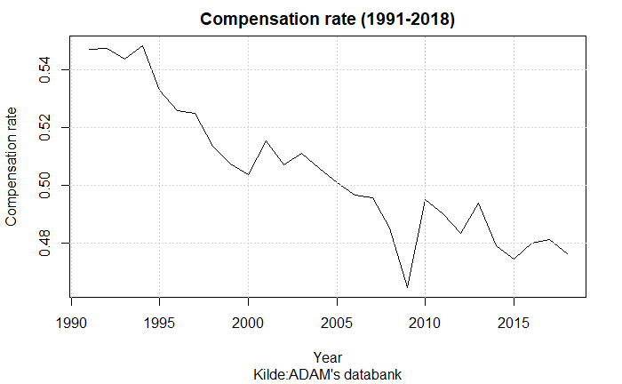

Aastrup (2018), Jensen (2021), and Risgaard (2021) all associate the fall in the compensation rate, to how growth in the maximum level of income insurance is calculated. In 1995 the Danish ministry of finance legislated a yearly regulation of unemployment benefits (Nørgaard, 1995). The regulation goes through the state regulation percent which is set to equal 2% each year added by the rate adjustment percent.   
The rate adjustment percent is each year set according to the adjustment percent which is calculated as the change in wages two years prior to the financial year subtracted by two percent points.   
If the adjustment percent is lower than 0%, the rate adjustment percent is equal to the adjustment percent. Is the adjustment percent between 0% and 0.3% the rate adjustment percent is 0%. Lastly, is the adjustment percent larger than 0.3% the rate adjustment percent is equal to the adjustment percent subtracted by 0.3 percent points.   
This creates a situation in which wage growth of more than 2% would result in the maximum level of income insurance not following the wage growth, making the compensation rate decline over time. The figure **Fejl! Henvisningskilde ikke fundet.** gives an idea of how often the wage has increased by more than two percent.

Figure

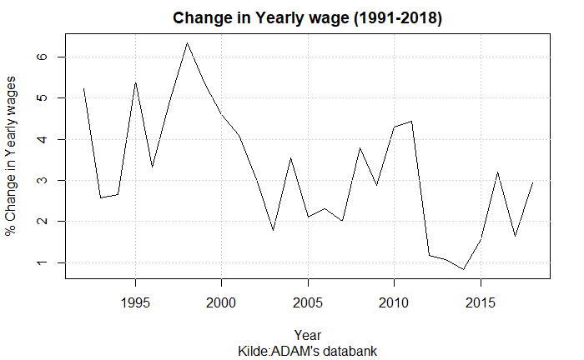

Even though the overall setup of the maximum level of income insurance, is made so that it doesn’t follow wages one-to one, a more recent regulation was made in the tax-reform of 2012 to suppress the regulation of the maximum level of income insurance. We already introduced this regulation in the introduction, explaining how this regulation further reduced the compensation rate starting from 2016, by subtracting up till 0.75% points from the state regulation percentage each year. As mentioned, this paper’s main goal will be to evaluate the decision to carry through this regulation from the tax reform 2012.

Other studies discuss whether an additional factor should be considered when looking at the compensation rate. When calculating the compensation rate the amount paid to labor market pensions from both the worker and employer is subtracted from the wage. Therefore, a larger share of the wage paid to labor market pensions will result in a higher rate of decrease in the compensation rate. One of the argumentations for including the development in the share of the wage paid to labor market pensions is that employed will benefit from their pensions later in their lives[4].   
This third effect is not included in the graph showing the compensation over time, including this effect should up the rate of decrease and thereby make the fall in the compensation rate even larger over time.

Despite the three main effects described above all contributing to a decrease in the compensation rate over time, other political decisions have been made towards the income insurance program over the last couple of decades. In 2010 the income Insurance reform was adopted, decreasing the period in which an unemployed could receive income insurance from 4 years till 2 years, as well as increasing the requirements for receiving income insurance (The IS-Commission, 2015a). Later, to make the cutoff date less strict, updates to the period in which a person could receive insurance were redone making it a smoother transition from the 4-year period to instead 2 years.   
A more recent initiative is made in 2022 making two important adjustments to the IS-program. First, increasing the amount one can get in the first 3 months for people with a strong working history. Second, lowering the amount one can get going directly from education to unemployment (DØRS, 2022). Even though these political decisions are important for the IS-program, the effects of these reforms will not be included in the analysis. Neither will they have any effect on the results found in this paper, as we use a set-up isolating the effects of suppressing the state regulation starting in 2016.

The discussion towards the Danish income insurance program peaked leading up to the Danish election in 2015. The large debate led to a commission set down by the Danish Ministry of employment (IS-commission). The goal was to analyze changes to the income insurance program in Denmark, which in 2015 led to the IS-model (income insurance model). The dynamics of this model were built using some of the micro effects presented in the previous section, estimating the change in the exit-rate and approach-rate as a result of changes in the level of income insurance. The results of this model favored the lower level of income insurance when looking at the government net lending and unemployment. This led to a response from worker unions and unemployment insurance companies in Denmark arguing that the estimates of the micro effects were not correctly estimated. But most importantly they argued that important macroeconomic effects were missing in the model. In the following subsection we take a closer look at the dynamics of the IS-model, as well as the critics faced by this model.

## The Danish Income Insurance model

In the previous subsection we gave a short introduction of the political regulations facing the Danish income insurance program through time. Since the creation of the Danish income insurance model in 2015, this model has been used by the Danish government, to analyze the effects of these regulations towards the Danish income insurance program. In this section we present the dynamics of the Danish income insurance model, to show which effects are taken into account when assessing political regulations towards the IS-program. Later in section 5 we will use the dynamics of this model, to obtain an estimate of the micro elasticity for Denmark, looking at how the suppressing of the state regulation percentage affects unemployment.

The IS-model consists of four different parts: A static model for income insurance, a static model for Cash-benefits[5], a Markovmodel, and lastly a re-earning model. Only the first three parts will be presented, as the re-earning model only concern changes towards the rules for re-earning the right to income insurance, thereby not looking at the level of income insurance.

The static model of income insurance is developed to calculate the immediate economic effects for a specific person being unemployed when changing the level of income insurance. For this reason, the static model will not include the behavioral changes that might happen, when creating changes in the IS-program. Similarly, the effect on cash-benefits is calculated using the static model for cash-benefits, to see if people would want to switch towards the cash-benefits program instead of the IS-program.

The more interesting part is the Markovmodel which is built to calculate the equilibrium levels of employment and unemployment, doing this, the population is divided into three groups: Receivers of income insurance, employed, and receivers of other social benefits. The Markovmodel estimates the probability of changing in-between the three groups, thereby looking at changes in the exit rate and approach rate. The exit-rate shows how a change in the level of income insurance changes the departure from unemployment to employment in the period up until the reduction and in the period immediately after. This effect is mostly concerned the unemployed with the best job opportunities to get off income insurance. The model is estimated using the 2010 reform mentioned in previous subsection which shows an effect on the exit-rate up till 78 weeks before a reduction in income insurance till 26 weeks after a reduction (Dagpengekommissionens sekretariat, 2015). These behavioral effects are specified as elasticities meaning that a relative change in the exit rate from unemployment to employment is a function of the relative change in the compensation rate. Thereby the effects of an increase in the level of income insruance of 30 and 10% will, following their estimates, have the effects of increasing the exit rate by 78% and 26%, at the time of change.

Besides the effect of the exit rate, the IS-commission also includes the approach rate. Here, the IS-commission looks at if people on their way into the income insurance program will find employment before entering the program. One issue is that data can’t show how many people are on their way to enter the income insurance program or how large the exit-rate to employment is for this group.

Therefore, the IS-commission must assume that the behavioral effects for people being close to going into the insurance program (for example from terminated positions) are comparable to the behavioral effects of people already being in the income insurance program and thereby have been in unemployment for up till 2 years[6].

The commission use this assumption to create a baseline for the exit rate to employment, for employed in terminated positions. In addition to this, three more assumptions are presented by DØRS (2022) used to construct the exit rate for this group:

1. They assume the exit rate is 0% 26 weeks before entering the income insurance program (as there are 6 months of termination period)
2. The exit rate is assumed to be linear going from 26 weeks before joining the program till the first week of joining the program
3. The exit rate is the same just before joining the insurance program as right after.

DØRS (2022) argues that there are missing empirical evidence for all three assumptions, they claim that people on income insurance might have more time for job searching than people being in terminated positions. On the other hand, they expect people being close to joining the income insurance program to increase their job search to avoid the fall in income.

DØRS (2022) presents the effects of a 10% decrease in the level of income insurance indicating a 26% increase in the exit rate for the start of the unemployment period as argued by The IS-Commission (2015a). This implies an increase in the weekly exit-rate by approximately 3.5% to 4.5% at the time of the 10% decrease in the level of income insurance. As this regards the exit rate for people in terminated positions it implies that less people will join the income insurance program. As significant effects are found up till 78 weeks before the change in the level of income insurance for the exit rate, changes in the level of income insurance in the first 78 weeks of the income insurance program will influence the approach rate. (With lower effects the later the increase appears)

The majority of the empirical evidence used for the IS-model comes from the literature review made by Andersen et al. (2015). This review was made specifically for the IS-commission, and therefore influenced the effects used in the IS-model. Andersen et al. (2015) specifically looks at the evidence for an effect on the exit-rate and approach rate when raising the level of income insurance. They present 28 different older and newer studies, all focusing on finding an effect on the exit rate, showing the percentage of people switching from the income insurance program to employment. When analyzing the effect of an increase in the level of income insurance, 24 of the studies conclude a significant negative effect of the exit rate, the last 4 studies conclude non-significant negative effects, overall, we find this to justify the use of the exit rate in the model, whereas this effect should be included when estimating the micro elasticity in section 5.

On the other hand, Andersen et al. (2015) only presents three studies looking at the approach rate when changing the level of income insurance, the two newest studies Falch (2015), and Jurajda (2002) finds no significant effects. Andersen et al. (2015) find that the only study showing significant effects is an older study by Topel (1983) using American retrospective data from 1975. This lack of empirical evidence has led to the large amount of critic towards the use of the approach rate.

Both Jensen (2021), and Aastrup (2018) argues that the behavioral effects (explained above) used to estimating the costs of an increase in the level of income insurance is miss leading. Especially they argue that the IS-commission is overstating the approach effects. They question whether a link between the level of income insurance and the approach-rate should even exist. The IS-Commission (2015b) also themselves mention that there is very low empirical evidence for this effect even existing.  
Risgaard (2021) add to the discussion that they don’t see the income insurance at a level where it should be pulling employed into unemployment, they argue that a large percentage of the group experiencing the highest level of compensation rate are still in job.

More recently DØRS (2022) concludes that based on new literature the estimate of the approach rate given by the IS-commission, when looking at changes in the level of income insurance, is overstating the negative effect that the approach rate has on employment. They split up the analysis into three scenarios one being a change in the level of income insurance. They claim that the reason for the miss leading effect might be that the IS-commission is only including one of four effects that should be affecting the approach rate when changing the level of income insurance.

As stated above the effect included by the IS-commission is that people in terminated positions will experience a higher exit rate when lowering the level of income insurance, thereby more people will go into employment before joining the income insurance program. The three other effects that DØRS (2022) argues should be added into the model are the following:

First, they claim that the commission is neglecting the possible effect of changes in the level of income insurance on job separation (the number of terminations or redundancies). As the higher level of income insurance will lower the costs for a worker losing his or her job. This could lead to a lower effort put in by the worker, increasing the change of the worker getting fired. Also, the fact that a higher level of income insurance could be a chance for the worker to reorganize his or hers working life, increasing the rate in which people go into the income insurance program. (Hopenhayn & Nicolini, 2009; Hopenhayn & Wang, 1996)

Second, the change in level of income insurance could also show an effect on the job creation rate by reducing the number of advertised vacancies, this effect can be caused by higher costs for the firms both because they may have to advertise more if the job search is lower due to an increase in the level of income insurance, or because of higher wages, as the level of income insurance plays in to the wage negotiations as discussed in section 2.

Third, they argue that the IS-model doesn’t allow the change in behavior of the employed and unemployed to affect other people’s situation. The model is only looking at the individual’s expected reaction to a change in the income insurance program.

Accounting for the critic faced by the IS-model regarding the approach rate, we will still be able to use the model to estimate the micro elasticity of income insurance on unemployment. This will be useful in section 5, as we can use the estimates from the IS-model with some adjustments towards the approach effect to estimate the micro elasticity for Denmark.

In the literature review we presented several important macroeconomic effects that should be considered when analyzing changes to the income insurance program. As the IS-model is not incorporating these, it is not possible to use this for estimating the macro elasticity. Therefore, In the next section we aim to introduce the five macroeconomic effects presented in the literature review in a stock-flow-consistent model, as this will enable us to calculate the elasticity of these macroeconomic effects on unemployment. We can then use the elasticity of these macroeconomic effects together with the micro elasticity to get an estimate of the total macro elasticity of income insurance on unemployment associated with suppressing the state regulation percentage starting from 2016.

# Section 4: Including macroeconomic effects in a quarterly Stock-Flow-Consistent model for Denmark.

In this section we will present the model built to analyze the macroeconomic effects described in section 2. For this, we utilize the features of a stock-flow consistent framework building upon the existing empirical stock flow consistent model for Denmark developed by Byrialsen et al. (2022). We start by presenting the fundamental equations in the model and later focus on the equations added to incorporate the income insurance program within the model. After creating a baseline model, we validate the results of this model by comparing the simulated variables with real data. Besides from the demand channel which will already be included in the baseline model, we later introduce a wage, labor force, productivity, and insurance rate channel within the model. Lastly, we look at a scenario where all the five channels are included. In all the scenarios we analyze how unemployment is affected by removing the suppressing of the state regulation percentage starting from 2016 quarter 1, as this will later allow us to calculate the elasticity of the level of income insurance on unemployment associated with these macroeconomic effects.

## Fundamental equations in baseline model

As Denmark is a small open economy with fixed exchange rates Byrialsen et al. (2022) adopt the small open economy assumptions within the model, allowing global shocks to affect the Danish economy, while at the same time domestic shocks are irrelevant for the global economy, thereby treating the global economy as exogeneous.  
The model consists of 5 institutional sectors: non-financial corporations, financial corporations, the government, households, and the rest of the world. As our focus is towards the dynamics of the labor market, it is worth noting that due to a high rate of employment, the Danish economy is very likely to face labor shortages in the labor market. In order to capture this Byrialsen et al. (2022) include a supply constraint in the labor market, where even small changes to the unemployment rate affects wages, and thereby prices.

As the subject of this paper is to evaluate the political decision of suppressing the state regulation percentage by using the macro elasticity of income insurance on unemployment, we will take a closer look at how unemployment is defined in the model. We use the same set-up as (Byrialsen et al. (2022) where unemployment is defined as the difference between the amount of people employed and the labor force, as seen below:

As the labor force is exogenous, the unemployment is highly dependent on the demand for employment. This indicates the demand-driven aspect of the model, where firms will hire workers to meet a certain demand. This implies that employment is determined by total production and the productivity of workers both measured in real terms.

Here we assume that real total production takes place in the non-financial corporations and is determined by the aggregate demand, as seen below

For this paper the main effects of income insurance will go through the household’s disposable income and into the consumption of the households (). We start at the net benefits of the households () in contrast to the model presented by Byrialsen et al. (2022) we split the net benefits up into two components () and () the later one determining the total amount received by households in income insurance, and the first determining all other benefits but income insurance received by households. The effect of the net benefits of the households then feeds into the disposable income through the component of current transfers ().

For the household’s consumption we find cointegration between the real consumption and both real disposable income and real financial wealth. Therefore, the consumption function is estimated using an error correction model, taking the following form:

Through the equations presented the baseline model already includes a channel in which changes to the level of income insurance affects the disposable income, affecting the consumption and thereby affecting the aggregate demand, from now on we will describe this as the demand channel. In appendix we have included a DAG (pg. **Fejl! Bogmærke er ikke defineret.**) presenting a simple overview of the dynamics within the model, but for now we will opt into presenting the central equations for incorporating the income insurance program into the model.

First, we will present the dynamics of the maximum level of income insurance () within the model. As the ministry of finance calculates the maximum level of income insurance once a year, we estimate it for the first quarter hereafter keeping it fixed. In the baseline model follows the political regulations stated in the introduction, where it follows that the maximum level of income insurance grows by the state regulation percentage () plus the rate adjustment percentage () each year.

As the Ministry of Finance determines the state regulation percentage, we choose to make it exogenous within the model. On the other hand, the rate adjustment percentage is calculated each year, using the adaption percentage, following the rules stated earlier in the introduction we set up three conditions: First, if the adaption percentage is lower than 0 the rate adjustment percentage is equal to the adaption percentage. Second, if the adaption percentage is between 0.0 - 0.3% the rate adjustment percentage is set to 0. Third, if the adaption percentage is above 0.3% the rate adjustment percentage is equal to the adaption percentage minus 0.3% points.   
As with , the rate adjustment percentage is calculated in the 1. quarter and held fixed to the end of the year.

The adaption percentage is calculated by taking the wage growth two years before the financial year subtracted by 2% point, it should be noted that we use the yearly wage growth which in the model is calculated using the 1. quarter, therefore, the adaption percentage is only calculated for 1. quarter and held constant for the rest of the year.

The endogenization of is now completed, allowing us to calculate the compensation rate within the model. The compensation rate is estimated as the fraction of the average amount an unemployed on income insurance would receive (), to the average wage received by workers ().

To calculate we use a simple OLS regression linking the maximum level of income insurance to the average benefits received by unemployed being a member of the IS-program. This is done as an alternative of using aggregated data of benefits received by households, as the gap between observed unemployment and estimated unemployment in the model at some points are quite large, thereby creating a lower average of benefits received. Looking at data from ADAM’s databank we know that approximately 85% receives the maximum level of income insurance. This implies that the 85% receiving the maximum level of income insurance will experience a one-to-one increase in their level of income insurance. On the other hand, people not getting the maximum level would experience a lower increase or even no increase at all in their level of income insurance, depending on whether the increase in the maximum level of income insurance is because of higher wages[7]. For this reason, we know that the coefficient should be between 0.85 and 1, which is also what we find when estimating the coefficient to be 0.9507 in the equation below.

The average level of income insurance is then transformed into an aggregate variable, multiplying it by the number of unemployed and the insurance rate[8] giving the total amount paid in income insurance to the households .

The total amount paid in income insurance to the households then feeds into the households’ disposable income, as earlier explained, this summarizes the demand channel created in the model for changes to the income insurance program, it should be noted that this effect is not accounted for in the IS-model.

The total amount of income insurance also feeds into the net lending’s of the government, here it is assumed that the government finances the entire IS-program, which is not the case in reality, the effect of a change in the level of income insurance will therefore overshoot the effect on government net lending[9].

Another key variable in the labor market is the participation rate, showing the ratio of the population being in the labor force. In the baseline model we keep this variable as exogenous. A main reason for having the participation rate exogenous in the baseline model is that within the dynamics of the Danish labor market many have failed to determine what brings people into the labor force, in section 2 the literature argued that participation could follow several factors, including norms, wages relative to other workers, consumption levels, and the standard of living. In Scenario 4, we look at a scenario in which the participation rate is made endogenous using the same method as Fazzari et al. (2020) who finds a significant relationship between the unemployment rate and the labor force.

## Validation of the model

In this section we look at the performance of the model, comparing the simulation results of the baseline model with actual data, we keep a specific focus on the variables in the labor market.

In the figures below we compare the simulated and actual data for GDP, Employment, maximum level of income insurance and the compensation rate.

Figure : Simulation vs. real data.

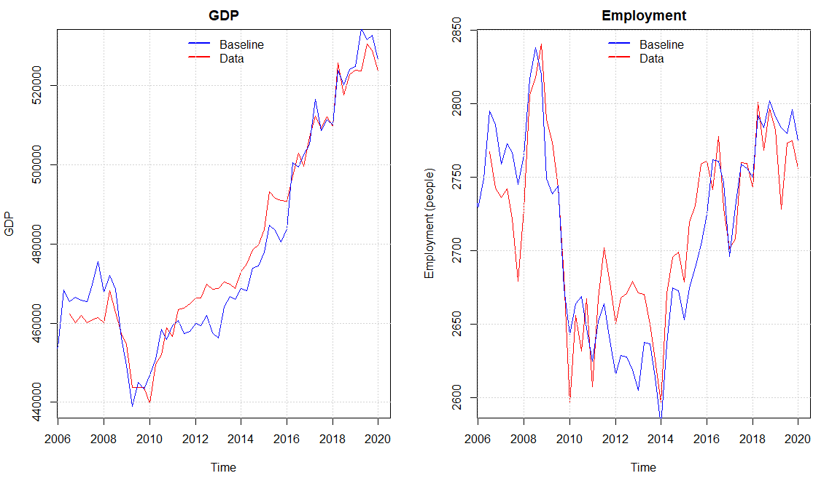

It seems like we capture the same dynamics of the real economy as Byrialsen et al. (2022) with a small overshooting of the economic activity in the period 2011 - 2016 explained by a higher simulated value of real investment and consumption compared with the data. Overall, the model seems to capture the medium to long-run tendency of the data even though there are some divergences in some quarters. The Overshooting in the activity also results in a higher level of the maximum level of income insurance in some periods when looking at the simulated data.  
 As the increase in wage growth goes directly into the compensation rate in the same period, meanwhile the maximum level of income insurance will be affected with a lag of 2 years, we observe that the compensation rate is a bit higher in the baseline compared with real data in the period of 2010 - 2012, but as the adjustments to the income insurance through higher wages happens we again find a good match with the real data.

Figure : Simulation vs. real data

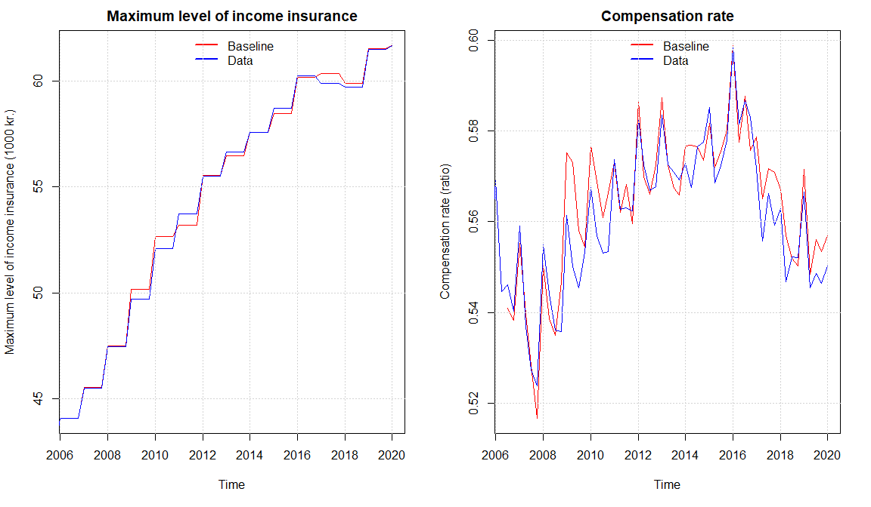

From the figure above we see that the compensation rate is slightly increasing, especially in the period of 2008-2016, we attribute this to a slowdown in the growth rate of wages. Comparing with the results of DØRS (2014) the development fits very well, they as well use a macro-based calculation of the compensation rate, finding that the compensation rate increases within this period. Most importantly, our baseline model shows a fall in the compensation rate in the period of suppressing the regulation of the maximum level of income insurance starting in 2016. Which was also expected looking at the forecasts made by DØRS (2014).

Overall, we see that the data for the labor market is well replicated by the model, creating a basis for analyzing the five macroeconomic effects presented in section 2, making it possible to estimate the macro elasticity of the level of income insurance on unemployment in section 5.

As mentioned above the demand channel as already been included within the baseline model, therefore when we start to analyze different channels independently it should be noted that the demand channel is still active. In scenario 1, we will perform a counterfactual analysis by removing the suppressing of the income insurance inn the baseline model. This will allow us to estimate effect on unemployment associated with the demand channel. Next, we start by including more channels for the income insurance to affect the economy. In scenario 2, we introduce a channel in which the maximum level of income insurance affects the targeted wage, thereby affecting the wage negotiation process. In scenario 3, we include the link between the compensation rate and the rate in which people want to be a member of the IS-program. In scenario 4, we endogenize the labor force using the unemployment rate as a regressor, thereby, we also allow for the participation rate to be endogenous within the model. In scenario 5, we will look at the match-effect (as a result of the liquidity effect) as well as the Verdoon effect, when endogenizing productivity within the model. In scenario 6, we introduce several of the channels together, allowing the effects of one channel to feed into the others.   
We would like to obtain the results of all the channels for the counter factual situation in which the suppressing of the state regulation percentage is removed, to be able to discuss these in the next section[10].

## Scenario 1 The effects of the Demand-channel.

In this first Scenario, we perform a counter factual shock in removing the suppressing of the state regulation percentage, determining the growth in the maximum level of income insurance. The state regulation percentage is usually fixed at 2% but due to the tax reform of 2012 it is subtracted by 0.3 percent points in 2016, 0.4 percent points in 2017, and 0.75 percent points in 2018-2020.   
Therefore, we introduce the shock by keeping it fixed at 2% for the entire period. As we perform this shock on the Baseline model, the only channel in which a higher level of income insurance will affect the economy is through the demand-channel. First, as we fix the state regulation percentage to 2%, we experience a higher growth in the maximum level of income insurance. We then observe an increase in the average level of income insurance as we included a direct link to this from the maximum level of income insurance[11]. As we include the average level of income insurance in the calculations of the compensation rate, we see both increase by approximately 3.5% in the period of 2016-2020. As the wages are not affected by the shock, we observe an increase in both variables of the same magnitude, which can be seen below.

Figure

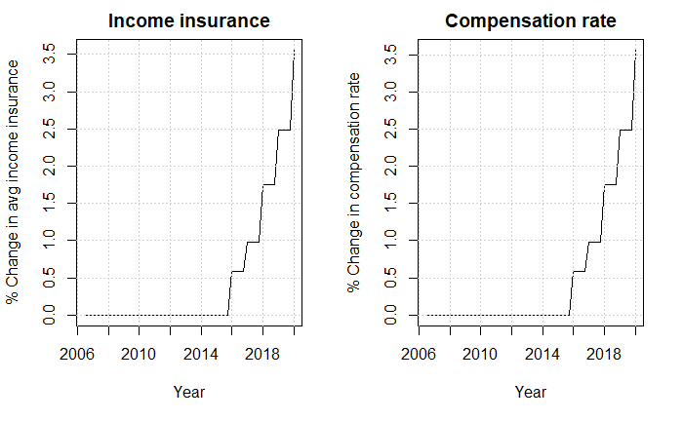

The increase in the average level of income insurance, increases the net social benefits received by the households, and thereby raises the disposable income of the households. As the increase in net social benefits for the households are financed by the government the net lending of the government will fall. These effects take into account the increased tax payments that the households will experience.

Figure

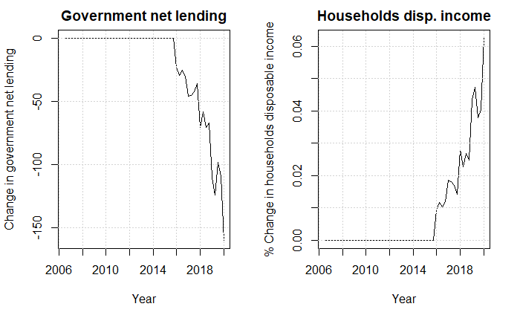

The increase in disposable income, increases the consumption and therefore also the GDP. The increase in GDP will increase the firms demand for workers and thereby raise employment.

Figure

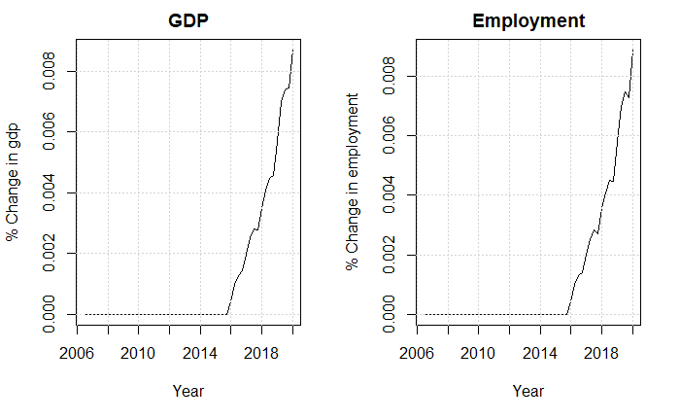

The only effect of removing the suppressing of the state regulation percentage in scenario 1 goes through the demand channel. As it is only a minor part of the population experiencing an increase in income, the macroeconomic effects are minimal, but still seems to expand the economy. Calculating the change in unemployment associated with the demand channel we estimate a fall of approximately 250 people.   
One of the most central estimates for the demand channel, is the one describing the relationship between the maximum level of income insurance and the average income insurance, estimated to be 0.95 in the baseline model. We know that the estimate should be between 0.85 and 1, but the exact value depends on whether the change in the maximum level of income insurance goes through the wages or not. As the change in this scenario is not going through the wages, it will only be the people receiving the maximum level of income insurance experiencing an increase, leaving the true estimate to be 0.85. Therefore, we perform a sensitivity analysis in appendix (pg. **Fejl! Bogmærke er ikke defineret.**) both including n lower and upper bound for this coefficient. Using an estimate of 0.85 we see that the result is almost the same as we find a decrease of unemployment off 223 people.

In scenario 2, we will introduce the wage channel in the model while still creating the same counterfactual scenario in removing the suppressing of the state regulation percentage.

## Scenario 2: Including the wage-channel

As presented in section 2, we find that incorporating the level of income insurance is in line with standard models of wage setting, thereby playing an important role in the determination of the targeted wage. In our model we assume that the labor unions got two agendas when determining the target wage. First, they want the wage to follow inflation so that workers keep their purchasing power over time. Second, they set a threshold for the minimum wage gap, measuring the difference between the wages and maximum level of income insurance relative to the wages, to maintain a certain incentive to stay employed. In the model we set the minimum wage gap to 42% of the wage, thereby, we estimate a relationship between income insurance and wages close to the one found by Fredriksson & Söderström (2020) showing an elasticity of 0.2-0.3. In the case where inflation is not able to close the minimum wage-gap alone (thereby leaving the gap to be below 42% of the wage), the labor unions set the targeted wage so that the wage gap is exactly 42% of the wage. The equation for the target wage and the wage gap can be seen below:

We then include the targeted wage as a regressor in the wage equation, estimating it to have a positive effect on the wage in the long run.   
Performing the same counter factual shock as in scenario 1, removing the suppressing of the state regulation percentage, we see that the targeted wage increases by almost 4% in 2020. When the workers unions then go into the wage negotiations with a higher targeted wage, this affects the wages estimated in the model. Furthermore, as firms are now experiencing higher costs, this will also increase the consumer prices. In the figures below we include the development of these three variables.

Figure

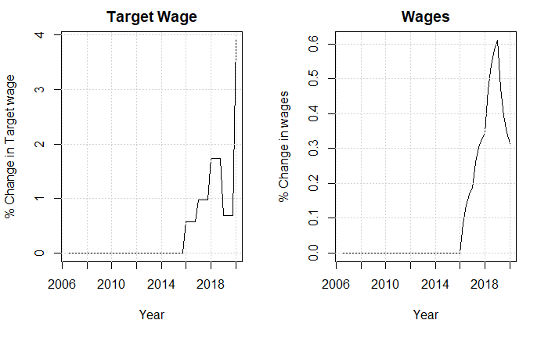

Figure

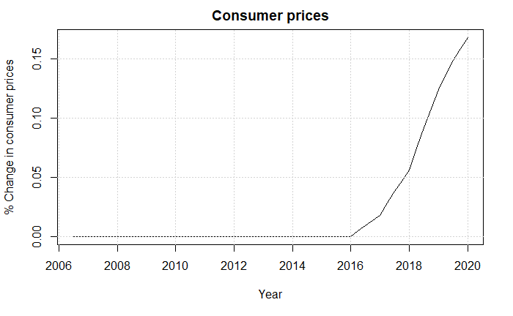

As the wages increase, so does the wage-share in the model. As argued by Onaran & Galanis (2012) the final effect of a rising wage-share (falling profit-share) in the end comes down to the effect on consumption, investments, and the net exports of the economy.

Looking at the investments first, we see that increasing the wages leads to an increase in the wage share thereby lowering the profit share, which will affect the investments through two channels. First of all, firms will experience a lower return on investments thereby decreasing the future investments.   
Secondly, when investments start falling there will be a larger capacity that the firms can utilize, while at the same time the lower investments also decrease the economic activity which decrease the capacity of the economy. These two adverse effects are captured by the capacity utilization rate, where it seems like the first effect is dominant leading to a small increase in capacity utilization which will increase the firms’ incentives to invest.

We find the last effect of the capacity utilization to be quite small whereas the overall effect will be a fall in investments, also observed in the plot below.

Figure

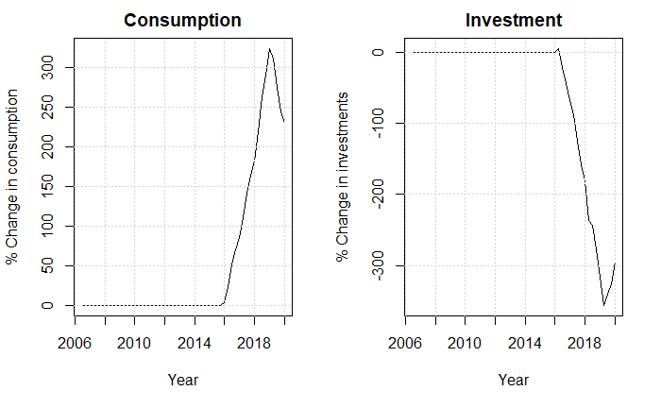

Looking at the effects of a higher wage-share on consumption, we find that as the propensity to consume is larger for wage income compared to profits, the consumption for the households will increase, also observed in the plot above.

At the end, we can conclude that the fall in investments is larger than the increase in consumption which is the same conclusion found by Onaran & Obst (2015) also looking at the case of Denmark.

The last effect of an increase in the wage-share is found on the net-exports, as the increase in the wages directly goes into the price equations, consumer prices will increase, resulting in lower exports, as well as increasing the imports. Even though the import starts to fall as the economic activity gets lower, we still observe a fall in the net-exports, as seen below.

Figure

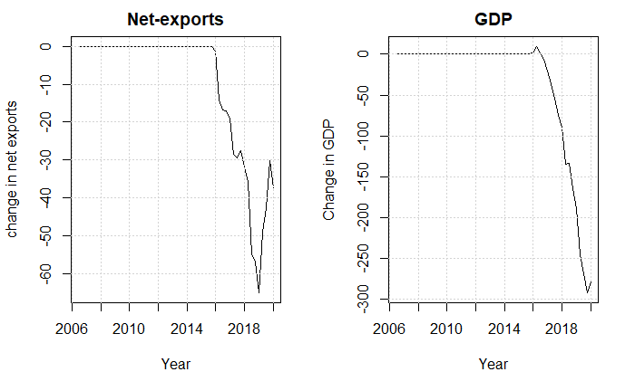

In total, we see that the increase in consumption is smaller than the decrease in the net-exports and investments, therefore, lowering the economic activity. The unemployment as a result of removing the suppressing of the state regulation percentage increases by approximately 1500 people in 2020[12]. In the next section we will add a new channel affecting the rate in which people want to be a member of the income insurance program.

## Scenario 3 Including the insurance rate-channel

In the baseline model the insurance rate ( was included as an exogenous variable, but as presented in section 2, many organizations criticize the IS-model for not including a relationship between the compensation and people’s choice in joining the insurance program[13]. Such an relationship should exist as people are comparing membership costs to the generosity of the program, and as the compensation rate gets lower, more people are not willing to pay these costs, thereby these people end up leaving the program (Aastrup, 2018; Jensen, 2021; Risgaard, 2021). The central mechanism of changes in the insurance rate, will go through the demand side of the economy as we change the percentage of people receiving income insurance when unemployed[14]. The equation added to the model can be observed below:

As noted previously the data used for the insurance rate is obtained from ADAMS databank, and as the data is only available till 2018, we are only able to estimate the equation till 2017 quarter 4. Doing this, we find a positive long-run relationship between the compensation rate and the insurance rate but are only significant at a 10% significance-level.

As the demand channel and insurance rate channel included in this scenario both affect the economy through the same equations, we will compare the results of this scenario with scenario 1. First, we see that the increase in compensation rate increases the incentive to join the insurance program whereas a higher percentage of unemployed are now receiving income insurance, increasing the net benefits received by the households. We can use the same reasoning as in scenario 1, where an increase in the net social benefits increased would result in a higher disposable income, while at the same time also increasing government net lending, both observed in the plot below.

Figure

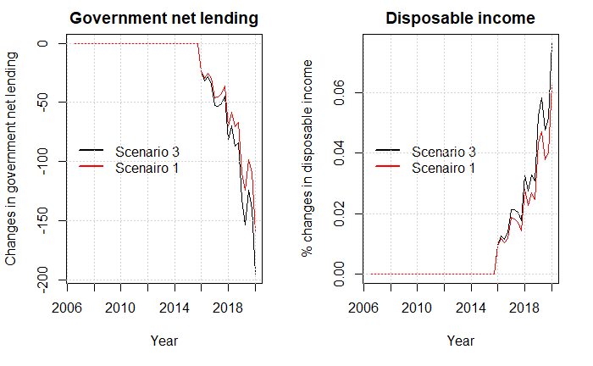

It shows that endogenizing the insurance rate, increases the demand effect that we saw in scenario 1. In the plot below we observe the effect on GDP with and without adding in the insurance rate-channel.

Figure

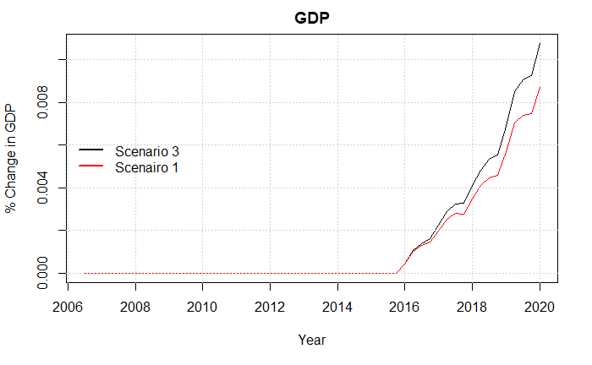

Lastly, when comparing the effects on unemployment, we further decrease unemployment comparing with the results of scenario 1. The total effect on unemployment when including this channel is a fall of 300 people, thereby extending the fall by 50 people compared with scenario 1.

## Scenario 4 Including the labor-force channel

In section 3 we described the two static models of income insurance and cash-benefits build by the IS-commission, where people would switch from the IS-program to the cash-benefits program, if the later one resulted in a higher level of benefits. As this effect is already accounted for in the IS-model and thereby the micro elasticity, we will not include this link in our model, instead we will use the effects used by Fazzari et al. (2020).

As mentioned, we set the participation rate exogenously within the baseline model, as the literature is still mixed in determining what explains the participation rate. We find significant relationship using the method presented by Fazzari et al. (2020) who endogenize the labor force in the model using the unemployment rate as a regressor, expect a negative relationship between the unemployment rate and the labor force. The main explanations used by Fazzari et al. (2020) for this negative relationship, is that a rising unemployment rate would indicate rising difficulties of finding acceptable job matches, which might create incentives for some people to stay outside the labor force. The new equation for the labor force can be seen below.

The labor force can then be used for calculating the participation rate in the Danish economy, using the equation below:

Comparing the simulated data with real data for the participation rate, we see that the model is able to capture the overall trend, shown in the figure below:

Figure

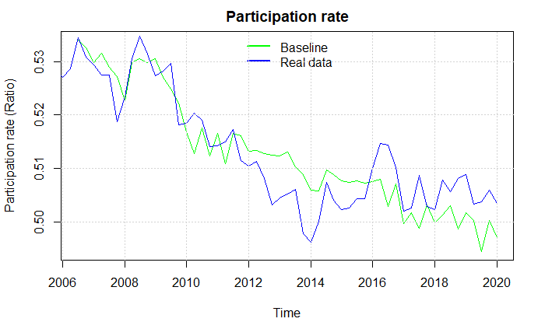

When removing the suppressing of the state regulation percentage after introducing the LF-channel we get almost the same results as in scenario 1, where we only included the demand channel. We saw that scenario 1 had a minimal effect on the unemployment rate, therefore the change in the labor force is also minimal increasing the labor force with 50 people, creating almost no difference in the two scenarios. When estimating the unemployment, we see a fall of approximately 150 people in this scenario[15], compared with 250 in scenario 1. In scenario 6 when introducing all effects together, this channel will play a larger role, as the unemployment rate will be more heavily affected.

## Scenario 5 Including the productivity channel

As argued by Chetty (2008), 60% of the change in the unemployment period due to changes in the level of income insurance can be attributed to the liquidity effect. Assuming this to be true, the existence of the liquidity effect creates a possible channel in the form of the matching effect, where increases in the level of income insurance affects the productivity, as unemployed are more financially robust to stay longer time in unemployment searching for a better job-match. As mentioned in section 2, empirical results only find weak evidence for the existence of the matching effect having an effect on the productivity, mostly because of the problem in finding realistic proxy variables to measure productivity. In the model, the effect is included by endogenizing the productivity function, using the level of income insurance per person as a regressor, as can be observed below. Also, the Verdoon-effect described by Millemaci & Ofria (2014) and mentioned in section 2 will be included. Like Fazzari et al. (2020), who also uses the Verdoon-effect, we control for wages as an explanation for a supply side factor explaining productivity, we find significant effects for all three regressors[16].

As the increase in the average level of income insurance now feeds directly into the productivity, we observe an increase in productivity compared to the baseline model after 2016, observed in the figure below.

Figure

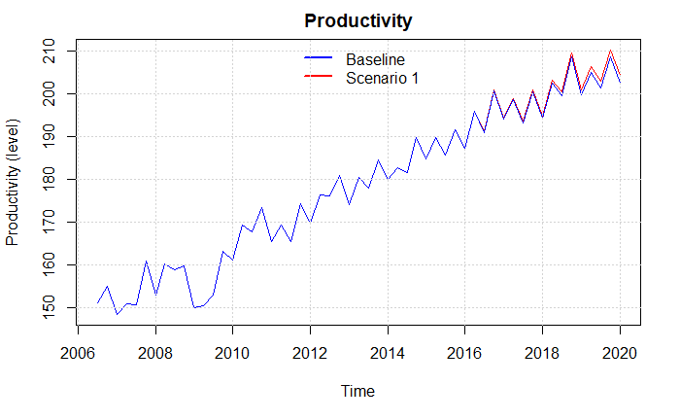

As the economy in a post-Keynesian SFC model is demand driven this goes for the labor market as well. Therefore, when increasing the productivity while having the same demand, firms will lower the number of workers to meet the same level of demand, therefore increasing the number of unemployed in the economy by around 25.000. Looking at the percentage change in unemployment this is a 15 percent increase, as also shown in the plot below, where we at the same time see the economic activity increase.

Figure

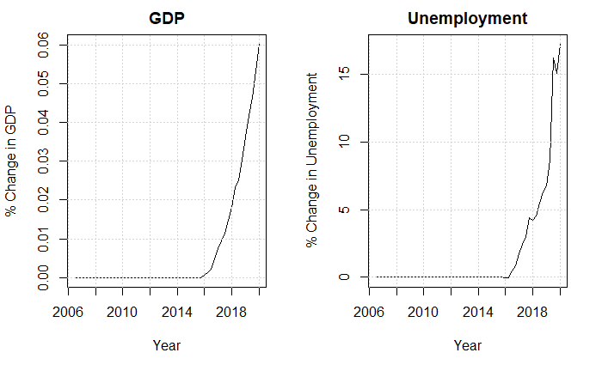

We find the effect of the productivity channel to be quite large, especially compared to the other effects of the previous scenarios. In section 2, we presented literature showing mixed results regarding the matching effect, most likely because most literature finds it problematic to find good measures of productivity (Andersen et al., 2015). In addition to this, Andersen et al. (2015) also present a reverse effect arguing that extending the unemployment period, should lower human capital. This effect seems hard to capture, as this is also affected by the active policy for the labor market. For this reason, we will exclude the productivity channel in the next scenario, when including multiple channels at once[17].

## Scenario 6: including multiple channels

In the previous scenarios, we have analyzed the five macroeconomic channels explained in section 2, looking at how they independently affected the economy, and most importantly for our paper, unemployment. Now, we will introduce a scenario including the channels from scenario 1-4 at once, as doing this will allow the effects of one channel to feed into other channels. Again, we will focus on the effects found on unemployment, but will also include the effects found on the government net-lending and GDP and compare the results with the previous scenarios. As argued in the previous section, we do not include the productivity channel in this scenario, as we find the results of this channel quite radical. At the same time, we also find the literature presented in section 2 to show mixed results of the matching effects, leaving us to not trust the effects found in the previous scenario.

Looking at the independent effects, we found the wage channel to be the most dominant also indicated in the plot below. But as we include the effects of scenario 1-4 together, we see a further increase of almost 1000 in unemployment, compared to when only including the wage channel as in scenario 2. We attribute this increase of 1000 people to the LF-channel, as the wage channel increases the unemployment rate, hereafter, decreasing the labor force by approximately 750 people. The decrease of the labor force then lowers the economic activity thereby lowering the employment. We find that the fall in employment is actually larger than the fall in the labor force, therefore increasing unemployment further. In the end the total effect on unemployment when including the channels from scenario 1-4 turns out to be an increase of 2362 people.

Figure

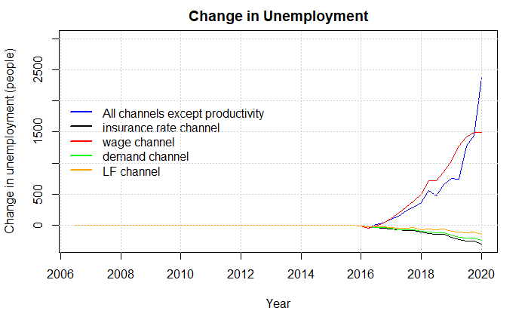

Looking at the change in Government net-lending, we see a large increase after 2018. This is due to the overall lower economic activity lowering the tax payments towards the government, as well as the higher amount of unemployed increasing the payments from the government towards the IS-program.

Figure

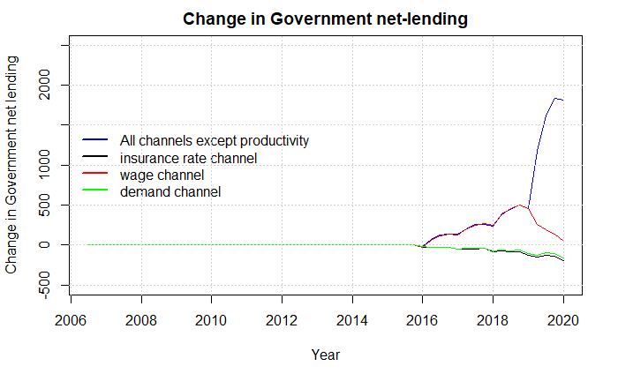

Turning to GDP, we observe a lower economic activity as people start leaving the labor force due to the higher unemployment, making the fall in GDP larger when including all channels but productivity.

Figure

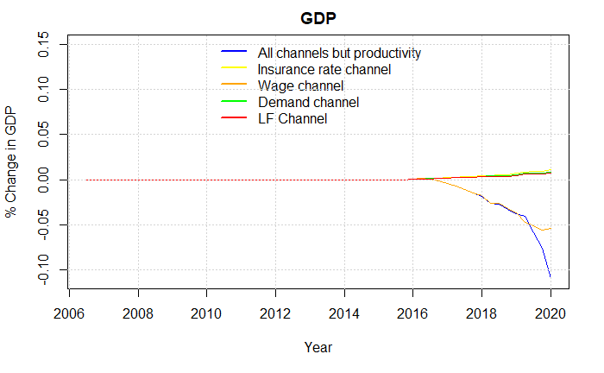

In the next section, we will use the results obtained from scenario 1-6 to get an idea of the relationship between the micro elasticity and macro elasticity of income insurance on unemployment. We can use the estimates of the IS-model, taking into account the critics of the approach rate, to calculate the micro elasticity for Denmark associated with the suppressing of the state regulation percentage. Also, we can use the results found in this section to estimate the elasticity of the macroeconomic effects, also associated with the suppressing of the state regulation percentage. The sum of these effects will then leave us with the macro elasticity of income insurance on unemployment, still associated with the suppressing of the state regulation percentage. Furthermore, We compare our findings with newer literature who also calculates the macro elasticity, here we will especially pay attention to the study by Fredriksson & Söderström (2020) who finds the macro elasticity for the Swedish economy.

# Section 5: Evaluating regulations towards the Danish income insurance program

In the previous section we introduced the five macroeconomic channels, presented in section 2, with the intention of analyze their effect on the unemployment when removing the suppressing of the state regulation percentage.  
In scenario 1, we found that removing the regulation resulted in a higher level of income insurance leading to a higher aggregated demand, thereby increasing GDP. As the employment is determined by the economic activity the increase in GDP decreased unemployment by 223 - 254 people.  
In scenario 2, we created a relationship between the income insurance and the targeted wage set by the worker unions. We used the argumentation that a higher level of income insurance would increase the targeted wage, thereby increasing wages. As we find the Danish economy to be categorized as profit-led, we find the increase in wages to lower GDP, thereby increasing unemployment by 1500 people, when removing the suppressing the state regulation percentage.  
In section 3, we introduced a relationship in which the level of income insurance affects the incentives to be part of the income insurance program, thereby increasing the insurance rate. When implementing this channel, we see an increase in the total amount of income insurance paid to households, reducing the number of unemployed by 300 people, following the same effects as explained for scenario 1.   
In section 4, the labor force channel was introduced creating a link between the strength of the economy and the labor force, as the unemployment rate falls due to the demand channel, we see an increase in the labor force leaving unemployment to fall by 150 people.   
In section 5, we added a channel allowing the level of income insurance, the strength of the economy, and the wages to affect productivity. As when we now see changes in the productivity, firms will adjust the number of workers to still meet the same demand. When removing the regulation, we find this effect to increase unemployment by 25000 people.

Finally in scenario 6, we allowed the channels of scenario 1-4 to interact resulting in an increase of 2362 people in unemployment. We exclude the productivity channel as we find the increase in unemployment of 25000 to be quite radical, this, together with the mixed results found by the literature for this channel led us to exclude it in scenario 6. In the appendix (pg. **Fejl! Bogmærke er ikke defineret.**) we show the effects of including the productivity channel together with the channels from scenario 1-4 finding that unemployment increases by 23.000 people[18]. For the rest of the discussion, we opt to exclude the effects of the productivity channel.

As presented in section 2, the literature regarding income insurance is moving more towards estimating the full macro elasticity, instead of the often-used micro elasticity found by the Danish income insurance model. To see the importance of estimating the macro elasticity, we start this discussion by presenting the current empirical results for the relationship between the micro and macro elasticity. We then estimate both the macro and micro elasticity for Denmark using the results of the IS-model as well as the results found in the previous section. Next, we use the elasticities to evaluate the political decision to suppress the state regulation rate, by using the framework of the Baily-Chetty function, looking at 3 different cases. Lastly, we discuss the two main assumptions made to obtain our findings.

## Finding the relation between the micro and macro elasticity for Denmark

When discussing a political regulation like suppressing the state regulation percentage, it is crucial to know the relationship between the macro elasticity and micro elasticity for the Danish economy. To the best of our knowledge, no previous study has compared these for Denmark. From a macroeconomic perspective, we therefore highly question the results obtained by the IS-model, which will only capture the micro economic effects of changes to the level of income insurance. For the general case Fredriksson & Söderström (2020) concludes that when not knowing the macro elasticity relative to the micro elasticity of income insurance it is not possible to make the right political decisions. If the macro elasticity equals the micro elasticity, then the Baily-Chetty formula applies directly (Baily, 1978; Chetty, 2006). If the macro elasticity is greater than the micro elasticity, and there are aggregate inefficiencies, then income insurance should be set lower than the level dictated by the Baily-Chetty formula. A key question is thus whether the macro elasticity is greater/lower or equal to the micro elasticity. (Fredriksson & Söderström, 2020)

Most literature touching on the relationship between the macro and micro elasticity is based on the analysis carried out in the US economy (Boone et al., 2021; Dieterle et al., 2021; Hagedorn et al., 2013, 2016). The majority of the literature use The Great Recession which brought a series of UI benefit extensions that were in many ways unprecedented in the United States (Dieterle et al., 2021). The results of these empirical tests are mixed and not giving a clear view of the relationship between the macro and micro elasticity. Dieterle et al. (2021) argues that the mixed results are mostly attributed to the use of causal effects methods, using boarder-based approaches[19]. These methods rely on two conditions: First, it requires that the areas being compared on either side of the border would experience similar labor market conditions in the absence of a difference in benefit level. Second, it also requires that the effect of the policy is concentrated on one side of the border, meaning the effects on one side of the border can’t spill over to the other side. They further argues that not all papers have been able to fulfill these conditions, making the results mixed (Dieterle et al., 2021).

We already introduced the study by Fredriksson & Söderström (2020) who use changes in the replacement rate of the wage when going to unemployment to obtain an estimate of the macro elasticity. They take advantage of the heterogeneity in high-wage and low-wage regions, where it is assumed that lowering the ceiling reduces benefit generosity more in high-wage regions, since high-wage regions also tend to be low-unemployment regions. Fredriksson & Söderström (2020) finds that the macro elasticity on unemployment in Sweden is twice as large as the micro elasticity with a macro elasticity of 3 compared to a micro elasticity of 1.4-1.5.

They argue that the main effect explaining the difference in the macro and micro elasticity is due to the higher wage pressure, following an increase in income insurance generosity. Fredriksson & Söderström (2020) show empirical evidence, that wages rise as a result of an increase in the celling for the maximum level of income insurance (replacement rate). Overall, the elasticity of interest is in the order of 0.2–0.3. They argue that the macroeconomic consequences of higher wages is that firms respond by creating fewer jobs, and so, market tightness is reduced increasing unemployment – over and above the direct effect coming from reduced search incentives among unemployed workers. But they fail to show any evidence for this channel as they do not test for a relationship between the replacement rate and vacancies. Another study looking at this relationship, is Marinescu (2017) finding no effect on vacancies when looking at the effects of a more generous income insurance program.

Just like Fredriksson & Söderström (2020), we also attribute the effect on wages as being the driving factor of creating a difference between the macro and micro elasticity for the Danish economy, as the wage-channel independently seems to have the largest effect on unemployment. As mentioned in scenario 2, we set the minimum gap allowed by worker unions so that it approximately matches the elasticity found by Fredriksson & Söderström (2020) of 0.2-0.3[20]. Instead of using the relationship between wages and vacancies explained by Fredriksson & Söderström (2020), we find significant evidence that wages affect the level of investment, consumption, and net exports as explained in scenario 2. As argued by Onaran & Galanis (2012) the effects found in scenario 2 goes through the wage-share, if an increase in the wage-share affects the economy positively, the demand regime is defined as wage-led; otherwise, the regime is categorized as profit-led. It is often found that small open economies (as Denmark) usually are categorized as profit-led, thereby expecting a contraction of the economy due to the negative effect on the net exports (Onaran & Galanis, 2012).   
Evidence for categorizing Denmark as profit-led is also found by Onaran & Obst (2015) showing that the Danish economy is profit-led, even as a closed economy[21], which is in line with the findings of our model[22]. On the other hand, a study by Bengtsson & Stockhammer (2018) finds the Danish economy to be weakly wage-led in the postwar period due to a smaller negative effect of investments on GDP. In this case, we should expect to find a decrease in unemployment, when including the wage channel in scenario 2, thereby changing the relationship between the macro and micro elasticity.

As we will now turn into calculating the macro elasticity for Denmark, we use the same idea as Lalive et al. (2015) where calculating the macro elasticity, is done by taking the sum of the micro effects and macro effects. So, if finding significant macro effects, as we do in our study, we can use those together with the micro effects of the IS-model to obtain an estimate of the macro elasticity[23].

We estimate the micro elasticity for the Danish economy using calculations presented by the ministry of employment, using the IS-model to provide the effects of removing the suppressing of the state regulation percentage in the period 2020-2023[24]. They estimate that removing this regulation will leave the level of income insurance to increase by 2.25%, and thereby lower employment by 2900 people[25]. This is further split up showing the effect associated with the exit-rate (1600 people) and the approach-rate (1300 people) independently (Hummelgaard, 2021). As mentioned by Jensen (2021) the approach rate is here contributes with 45% of the total effect, which they find to be very unrealistic.

When estimating the micro elasticity, we therefore include different measures of the approach effect in our analysis. Besides following the estimates of the IS-model (where the approach rate contributes with 45%), we also include the results found by DØRS (2022) who argues that the estimate used in the IS- model is twice as large compared to what newer literature suggests. Additionally, we will include the case in which the approach effect is not present at all as argued by literature presented in section 2 (Aastrup, 2018; Jensen, 2021; Risgaard, 2021).

Based on the three measures of the approach effect, we use the answer given by the ministry of labor above to calculate three different measures of the micro elasticity. First, we use the estimates given by the ministry of labor where a 2.25% increase in the level of income insurance increases unemployment by 2900 people resulting in a micro elasticity of 0.66. Second, we use the argumentation from DØRS (2022) of lowering the effect on the approach rate to half the size, the same increase in the level of income insurance now only increase unemployment by 2250 people reducing the estimate of the micro elasticity to 0.51. Lastly, when removing the effect on the approach rate entirely as argued by Jensen (2021), Aastrup (2018), and Risgaard (2021) we find the increase in unemployment to be of 1600 people, further reducing the micro elasticity to 0.36.

We now obtained three different estimates of the micro elasticity and opt into calculating the macro elasticity. Here we have the option to add the effects of the different channels independently, which will make it easier to pinpoint which effects are contributing with how much, or instead use scenario 6 including the channels from scenario 1-4. We choose to use the results of scenario 6, but still use the channels independently to get an idea of how much each channel contributes to the total effect. Using the percentage change in the level of income insurance, as well as the percentage change in unemployment found in scenario 6, we estimate the macro elasticity to be approximately 0.35-0.4[26]. As we find the estimate to be positive, it implies that the macro elasticity in Denmark is larger than the micro elasticity, thereby finding results comparable to the findings of Fredriksson & Söderström (2020). As we find the micro elasticity using the argumentation from DØRS (2022) to be the most realistic, this leaves us with an macro elasticity of 0.86-0.91. Thereby, we also find the macro elasticity to be twice as large as the micro elasticity, which was also found by Fredriksson & Söderström (2020).

At the start of the regulation period in 2016, the government faced the elasticity found above of 0.66. Using our own results, we instead estimate the elasticity to be in the range of 0.86-0.91 taking into account the lower approach effect, as well as macroeconomic effects. In the next section, we can now use these results in the framework of the Baily-Chetty function to see if we reach different conclusion when evaluating the political decision to suppress the state regulation percentage.

## Evaluation of the suppressing of the state regulation percentage.

In the previous section we obtained an estimate of the macro and micro elasticity for Denmark, looking at the relationship between these two, we find it to be very close to the one found by Fredriksson & Söderström (2020) for the Swedish economy. We now pursue using this new information to evaluate the political decision to suppress the state regulation percentage starting from 2016. We intent to do this by using the framework of the Baily-Chetty function, which evaluates the benefit level by using three important parameters. First, the elasticity of unemployment with respect to benefits ([27]Second, the drop in consumption as a function of benefits ( ), and third a coefficient of relative risk aversion (). Below we see the set-up of the Baily-Chetty function also presented by DØRS (2014) ho use it for the case of Denmark.

against

The idea of the function is to measure the marginal gains, in the form of higher compensation when going from employment to unemployment (the left side). Relative to the marginal costs, in the form of a lower level of employment opportunities (the right side). DØRS (2014) use this formula in the case of Denmark, using the compensation rate as a proxy for the change in income when going from employment to unemployment. They also argue that setting the relative risk aversion is tough for Denmark, but literature seems to use 1 or values a bit above 1. Looking at the elasticity of income insurance on unemployment DREAM (2013) estimates the elasticity to be approximately 1.5 looking across different countries. Finkelstein & Chetty (2012) estimates a quite lower elasticity of only 0.5 which is more in the range of our results for the micro elasticity. DØRS (2014) themselves use an elasticity close to 1 for the case of Denmark, which is close to the macro elasticity we find when summing together the micro elasticity with the elasticity of the macroeconomic effects found in section 4.

An explanation for why so different estimates of the elasticity is obtained by the literature is given by Chetty (2006). He argues that the size of the elasticity can depend on the type of shock performed, as we use a counter factual scenario for estimating the macro elasticity, we should get the elasticity associated with precisely this political initiative. This is a further argumentation for using the results of this paper, as these are associated with removing the suppressing of the state regulation percentage.

We now introduce 3 different cases looking at the relationship between the marginal gain and marginal costs in the Baily-Chetty framework. We already presented the calculation of the micro and macro elasticities that we wish to use in the Baily-Chetty function but we still need an estimate of the change in consumption going from employment to unemployment, here we do as DØRS (2014) and use the compensation rate showing the relationship between wages and the average level of income insurance. Additionally, we set the unemployment rate to 5%[28] and find that small changes to the unemployment rate will not affect the conclusions in the different cases. Lastly, we set the relative risk aversion parameter to 1 as done by DØRS (2014) for the case of Denmark. We will now present the three cases, where the parameters used in each case is presented in the figure below :

1. In the first case, we look at the problem from the perspective of the income insurance companies and worker unions. As they argue that changes in the level of income insurance should have no effect on the approach rate, we use the associated micro elasticity calculated above of 0.31. Furthermore, we use the compensation rate calculated by Aastrup (2018) to be 0.55 in 2016[29].
2. In the second case, we use the results obtained by the IS-commission using the estimates of the IS-model. Based on the question asked towards the ministry of labor we use the micro elasticity of 0.66. Additionally, we use the compensation rate calculated by the IS-commission with the latest estimated value being 0.51 in 2012.
3. In the third case, we include the parameters we expect to be the most realistic when evaluating the political regulation. Here we use the new information presented by DØRS (2022) towards the effect on the approach rate, resulting in a micro elasticity of 0.51. We add this to the elasticity found in this paper of the macroeconomic effects, using an estimate of 0.38, resulting in a total macro elasticity of 0.89. We use the compensation rate from the simulation in scenario 6, leaving us with a compensation rate of 0.57 for 2016 when the shock was introduced.

Table : Estimates used in the 3 cases

|  |  |  |  |  |
| --- | --- | --- | --- | --- |
| Case: |  |  |  |  |
| Case 1 | 0.55 | 0.36 | 1 | 0.05 |
| Case 2 | 0.52 | 0.66 | 1 | 0.05 |
| Case 3 | 0.57 | 0.51 + 0.38 = 0.89 | 1 | 0.05 |

**Case 1**

Using the estimates argued by the income insurance companies, and presented in the table above, we estimate the marginal gains to be 0.55, and the marginal costs to be 0.38. As we find the marginal gains to be larger than the marginal costs, we conclude that removing the regulation has a negative effect on the economic welfare. Which fits well into the overall argumentation from these organizations, who also wish to increase the compensation rate over time.

**Case 2**

Using only the estimates argued by the IS-model, thereby not taking into account the critics of the approach rate as well as neglecting macroeconomic effects, we calculate the marginal gains to be 0.52 and thereby lower than the estimate for the marginal costs being 0.69. This leaves us to validate the political decision to suppress the state regulation percentage looking at the economic welfare.

**Case 3**

Using what we find to be the most realistic estimate of the micro elasticity together with the elasticity of the macroeconomic effects found in this paper, we get the estimate of the marginal gains to be 0.57 and thereby lower than the estimated value of the marginal costs being 0.96. We reach this conclusion as the magnitude of the positive estimate for the macro elasticity is larger than the reduction in the micro elasticity coming of the lower approach rate as argued by DØRS (2022). Based on this result, we find that the government is choosing the economically optimal solution in lowering the compensation rate over time, by suppressing the state regulation percentage.

It is though very important to highlight that this result heavily rely on the assumption that the elasticity of the level of income insurance on wages in Denmark, is the same as the elasticity found by Fredriksson & Söderström (2020) for the Swedish economy. Adding to this, the elasticity found in Sweden is based on changes in the ceiling for the maximum level of income insurance, making the comparability with our results more complicated.  
One way to try and overcome these uncertainties is to include the average level of income insurance directly into the wage equation, to get an estimate of how the level of income insurance affects the wages in Denmark, doing this we find no significant long-run effects between the level of income insurance and wages. Using this as an argument to exclude the wage-channel when estimating the macro elasticity, we instead obtain an elasticity for the macroeconomic effects of approximately -0.04 instead of 0.35-0.4 as presented above leaving us with a macro elasticity of 0.47. If we instead use this estimate in case 3, we reach the opposite conclusion where the marginal gains from increasing the level of income insurance exceeds the marginal costs, favoring the argumentation used by the income insurance companies in increasing the compensation rate, thereby making the decision to suppress the state regulation percentage non optimal looking at the economic welfare.

In the end, our results found in case 3 validating the political decision to suppress the state regulation percentage rely on two critical assumptions. First, that our findings of Denmark being categorized as profit-led, holds, we find the literature to be split regarding determining the demand regime for Denmark, but as the results based on our model seems to be very robust, we are not concerned about this assumption.   
It gets more critical for the next assumption, as the results of our paper rely on the ability of worker unions to raise wages when the gap between wages and income insurance gets small, the theoretical as well as empirical evidence for this seems to be strong (as presented in section 2), whereas we set the minimum gap that the worker unions will allow according to the results found by Fredriksson & Söderström (2020). If we on the other hand rely on our own estimates when including the level of income insurance into the wage equation, we find no significant long run relationship, using this as an argumentation to exclude the wage-channel, we end up with the opposite conclusion for case 3, that suppressing the state regulation percentage lowers the economic welfare.

# Section 6: Conclusion

The generosity of the Danish income insurance program has been heavily debated over the last decade, especially leading up to the Danish election of 2015. The debate has mostly been driven by the fall in the compensation rate over the last 30 years and was accelerated due to the tax reform of 2012, lowering the state regulation percentage starting from 2016. In 2015, the debate resulted in a commission set down to analyze the Danish income insurance program, the outcome being the Danish income insurance model. This model was built on aggregated micro effects, based on a literature review made by Andersen et al. (2015). The income insurance model incorporates both the effect on the exit-rate and the approach-rate for changes in the level of income insurance, but due to a lack of empirical evidence for the effect on the approach rate the model faced major critics from especially income insurance companies, arguing to leave out the effect on the approach rate (Aastrup, 2018; Jensen, 2021; Risgaard, 2021). Looking at newer literature DØRS (2022) finds evidence that the effect on the approach rate is only half the size, compared to what is found in the income insurance model.   
Besides the critics associated with the approach rate, the income insurance model also faces major critics for not incorporating macroeconomic effects. Both DØRS (2022) and Andersen et al. (2015) mention that the literature has moved away from the narrow micro effects resulting in the micro elasticity, towards including macroeconomic effects, and thereby obtaining the macro elasticity of income insurance on unemployment.   
In this paper we introduced five possible macro channels in which changes to the level of income insurance would affect the economy, the five channels included the effect on demand, wages, insurance rate, labor force, and productivity, by include the channels in a quarterly Stock-Flow-Consistent model for the Danish economy, building upon the work of Byrialsen et al. (2022), we were able to estimate the effect on unemployment associated with each channel. We did so, by introducing 5 scenarios where we independently tested the macro effects when removing the suppressing of the state regulation percent starting from 2016. Based on the results of these scenarios, we chose to exclude the productivity channel due to a lack of empirical evidence as well as finding quite unrealistic results, thereby leaving the wage-channel to be the most dominant channel increasing unemployment by 1500 people independently of the other channels. In a 6th scenario, we then included the macro effects from scenario 1-4 together leaving unemployment to increase by 2362 people, we use this result to estimate the elasticity of these 4 macroeconomic channels, getting an estimate of 0.35-0.4. Now, to be able to estimate the macro elasticity of income insurance on unemployment, we only needed an estimate of the micro elasticity.  
 We find three different estimates of the micro elasticity depending on what measure we use for the approach effect. Using the effects from the income insurance model we find the micro elasticity to be 0.66, using the newer literature presented by DØRS (2022) we find the micro elasticity to be 0.51, and lastly using the argumentation from Aastrup (2018), Jensen (2021), and Risgaard (2021) we find the micro elasticity to be 0.31. As we find the argumentation made by DØRS (2022) to be the most trustworthy, we find the more realistic estimate to be the one of 0.51. Using the same idea as Lalive et al. (2015) calculating the macro elasticity by taking the sum of the micro effect and macro effects we obtain a macro elasticity of 0.89.

Lastly, we compare the estimated micro elasticity based on the results of the IS-model (elasticity of 0.66), and the income insurance companies and worker unions (elasticity of 0.31), with the results we obtained of a macro elasticity of 0.89. We do this by seeing if we reach different conclusions when evaluating the decision to suppress the state regulation rate using the Baily-Chetty function. In each of the three cases, we use the Baily-Chetty function to find both the marginal gains and marginal costs. Looking at the first case, using the results based on the argumentation of the income insurance companies and worker unions, we find that the suppressing of the state regulation percentage reduces economic welfare, while on the other hand, using the estimates presented by the income insurance model, we find that the regulation increases economic welfare.

In the third case, using the macro elasticity found in this paper, we find the regulation to increase the economic welfare, thereby validating the decision to suppress the state regulation percentage. We reach this conclusion relying on two assumptions. First, that we find the Danish economy to be categorized as profit-led when wages increase, leading to the wage-channel increasing unemployment as a result of a lower profit share. We find the literature to be split in determining the Danish demand -regime, but as we find our result from the model, indicating that Denmark is categorized as profit-led, to be very robust in our model, we rely on this result.   
Second, we assume the worker unions in Denmark to be capable of affecting wages when the gap between the level of income insurance and wages gets below a certain threshold. Even though we find empirical evidence for this in the literature, there seems to be no significant relationship between the level of income insurance and wages, using our own data for Denmark. This suggests that we should leave out the wage-channel when estimating the total macro elasticity. Doing this we obtain an estimate of 0.47 instead of 0.89, thereby resulting in the opposite conclusion, leaving the political decision to suppress the state regulation percentage to lower the economic welfare.

# Reference list

Aastrup, M. (2018). *30 Års dagpengeforringelser*. *September 2018*.

Andersen, T. M., & Svarer, M. (2006). Flexicurity: The Danish Labour-Market Model. *Ekonomisk Debatt*, *1*(April), 17–29.

Andersen, T. M., Svarer, M., & Vejlin, R. M. (2015). Litteraturreview af effekter af indretning af arbejdsunderstøttelsen. *Beskæftigelsesministeriet*, 1–99.

Bengtsson, E., & Stockhammer, E. (2018). Wages, Income Distribution and Economic Growth: Long-Run Perspectives in Scandinavia, 1900–2010. *Review of Political Economy*, *33*(4), 725–745. https://doi.org/10.1080/09538259.2020.1860307

Boone, C., Dube, A., Goodman, L., & Kaplan, E. (2021). Unemployment Insurance Generosity and Aggregate Employment. *American Economic Journal: Economic Policy*, *13*(2), 58–99. https://doi.org/10.1257/pol.20160613

Byrialsen, M. R., & Raza, H. (2018). Macroeconomic effects of unemployment benefits in small open economies: A stock–flow consistent approach. *European Journal of Economics and Economic Policies: Intervention*, *15*(3), 335–363. https://doi.org/10.4337/ejeep.2018.0032

Byrialsen, M. R., Raza, H., & Valdecantos, S. (2022). *QMDE : A QUARTERLY EMPIRICAL MODEL FOR THE DANISH ECONOMY : A STOCK-FLOW CONSISTENT APPROACH*. *79*.

Chetty, R. (2006). A general formula for the optimal level of social insurance. *Journal of Public Economics*, *90*(10–11), 1879–1901. https://doi.org/10.1016/j.jpubeco.2006.01.004

Chetty, R. (2008). Moral hazard versus liquidity and optimal unemployment insurance. *Journal of Political Economy*, *116*(2), 173–234. https://doi.org/10.1086/588585

Danish Ministry of Taxation. (2012). *Aftale om skattereform*. 1–28.

Danmarks Statistik. (2012). ADAM - En Model Af Dansk Økonomi. In *Danmarks Statistik*. Danmarks Statistik. https://www.dst.dk/da/Statistik/Publikationer/VisPub?cid=17987

Dieterle, S., Bartalotti, O., & Brummet, Q. (2021). Revisiting the Effects of Unemployment Insurance Extensions on Unemployment: A Measurement Error-Corrected Regression Discontinuity Approach. *SSRN Electronic Journal*, *11496*. https://doi.org/10.2139/ssrn.3177370

DØRS. (2014). *Dansk økonomi. Efterår 2014 : Konjunkturvurdering ; Dagpengesystemet*.

DØRS. (2022). *RAPPORT FRA FORMANDSKABET DANSK ØKONOMI FORÅR 2022*. https://dors.dk/raad-vismaend/loven.

Dray, M., & Thirlwall, A. P. (2011). The endogeneity of the natural rate of growth for a selection of Asian countries. *Journal of Post Keynesian Economics*, *33*(3), 451–468. https://doi.org/10.2753/PKE0160-3477330303

DREAM. (2013). *Langsigtet økonomisk fremskrivning 2013*. *August*.

Falch, N. S. (2015). *Three essays on unemployment insurance*. *April*.

Fazzari, S. M., Ferri, P., & Variato, A. M. (2020). Demand-led growth and accommodating supply. *Cambridge Journal of Economics*, *44*(3), 583–605. https://doi.org/10.1093/cje/bez055

Finansministeriet. (2017). *Det danske pensionssystem nu og i fremtiden*.

Finkelstein, A., & Chetty, R. (2012). *SOCIAL INSURANCE: CONNECTING THEORY TO DATA*.

Fredriksson, P., & Söderström, M. (2020). The equilibrium impact of unemployment insurance on unemployment: Evidence from a non-linear policy rule. *Journal of Public Economics*, *187*, 104199. https://doi.org/10.1016/j.jpubeco.2020.104199

Gutierrez, I. A. (2016). Job insecurity, unemployment insurance and on-the-job search. Evidence from older American workers. *Labour Economics*, *41*, 228–245. https://doi.org/10.1016/j.labeco.2016.05.011

Hagedorn, M., Karahan, F., Manovskii, I., & Mitman, K. (2013). Unemployment Benefits and Unemployment in the Great Recession: The Role of Macro Effects. *SSRN Electronic Journal*. https://doi.org/10.2139/ssrn.2340678

Hagedorn, M., Manovskii, I., & Mitman, K. (2016). Interpreting Recent Quasi-Experimental Evidence on the Effects of Unemployment Benefit Extensions. *NBER Working Paper Series*, 24. http://www.nber.org/papers/w22280

Hopenhayn, H. A., & Nicolini, J. P. (2009). Optimal unemployment insurance and employment history. *Review of Economic Studies*, *76*(3), 1049–1070. https://doi.org/10.1111/j.1467-937X.2009.00555.x

Hopenhayn, H. A., & Wang, C. (1996). Unemployment insurance with moral hazard in a dynamic economy A comment. *Carnegie-Rochester Conference Series on Public Policy*, *44*, 43–46. https://doi.org/10.1016/s0167-2231(96)90003-2

Howell, D., & Azizoglu, B. (2011). Unemployment Benefits and Work Incentives: The U.S. Labor Market in the Great Recession. *Political Economy Research Institute*, *257*, 151–162. https://doi.org/10.4324/9781315143842

Hummelgaard, P. (2021). *Spørgsmål nr:270*. Beskæftigelses Ministeriet. https://www.ft.dk/samling/20201/almdel/beu/spm/270/svar/1776624/2384360/index.htm

Jensen, M. T. (2021). *Prisen for at løfte dagpengene overdrives*. 1–10.

Jurajda, Š. (2002). Estimating the effect of unemployment insurance compensation on the labor market histories of displaced workers. *Journal of Econometrics*, *108*(2), 227–252. https://doi.org/10.1016/S0304-4076(01)00135-X

Kongshøj, P. (2015). *Dansk fl exicurity under pres – både indefra og udefra*. *1*, 5–10.

Lalive, B. R., Landais, C., & Zweimüller, J. (2015). *Market Externalities of Large Unemployment Insurance Extension Programs Author ( s ): Rafael Lalive , Camille Landais and Josef Zweimüller Source : The American Economic Review , Vol . 105 , No . 12 ( DECEMBER 2015 ), pp . 35*. *105*(12), 3564–3596.

Lavoie, M., & Godley, W. (2012). Monetary Economics - An Integrated Approach to Credit, Money, Income, Production and Wealth. In *Https://Medium.Com/*. https://medium.com/@arifwicaksanaa/pengertian-use-case-a7e576e1b6bf

Marinescu, I. (2017). The general equilibrium impacts of unemployment insurance: Evidence from a large online job board. *Journal of Public Economics*, *150*, 14–29. https://doi.org/10.1016/j.jpubeco.2017.02.012

Mcdonald, I. M., & Solow, R. M. (1981). *Wage Bargaining and Employment*. *71*(5), 896–908.

Millemaci, E., & Ofria, F. (2014). Kaldor-Verdoorn’s law and increasing returns to scale: A comparison across developed countries. *Journal of Economic Studies*, *41*(1), 140–162. https://doi.org/10.1108/JES-02-2012-0026

Nørgaard, T. (1995). *Bekendtgørelse om fastsættelse og regulering af omregningssats*. https://www.retsinformation.dk/eli/lta/1995/1154

Onaran, O., & Galanis, G. (2012). Is aggregate demand wage-led or profit-led? *Conditions of Work and Employment Series*, *40*(40).

Onaran, O., & Obst, T. (2015). *Wage-led growth in the EU15 Member States: the effects of income distribution on growth, investment, trade balance, and inflation*. 1–48.

Risgaard, L. (2021). *Mere tryghed til lønmodtagerne*.

Setterfield, M. (2003). Supply and Demand in the Theory of Long-run Growth: Introduction to a symposium on demand-led growth. *Review of Political Economy*, *15*(1), 23–32. https://doi.org/10.1080/09538250308440

Shapiro, B. C., & Stiglitz, J. E. (1984). American Economic Association Equilibrium Unemployment as a Worker Discipline Device. *The American Economic Review*, *74*(3), 433–444.

Stockhammer, E., & Lavoie, M. (2013). Wage-led Growth. In *Wage-led Growth* (Issue February). https://doi.org/10.1057/9781137357939

The IS-Commission. (2015a). *Dagpengemodellen teknisk analyserapport*.

The IS-Commission. (2015b). *Kompensationsgraden i dagpengesystemet*. 41.

Topel, B. R. H. (1983). *On Layoffs and Unemployment Insurance Author ( s ): Robert H . Topel Source : The American Economic Review , Sep ., 1983 , Vol . 73 , No . 4 ( Sep ., 1983 ), pp . 541- Published by : American Economic Association Stable URL : https://www.jstor.org/stable/*. *73*(4), 541–559.

# Appendix

## Appendix 1: DAG

Figure A1‑: A simple directed acyclic graph of the SFC-model used in this paper.

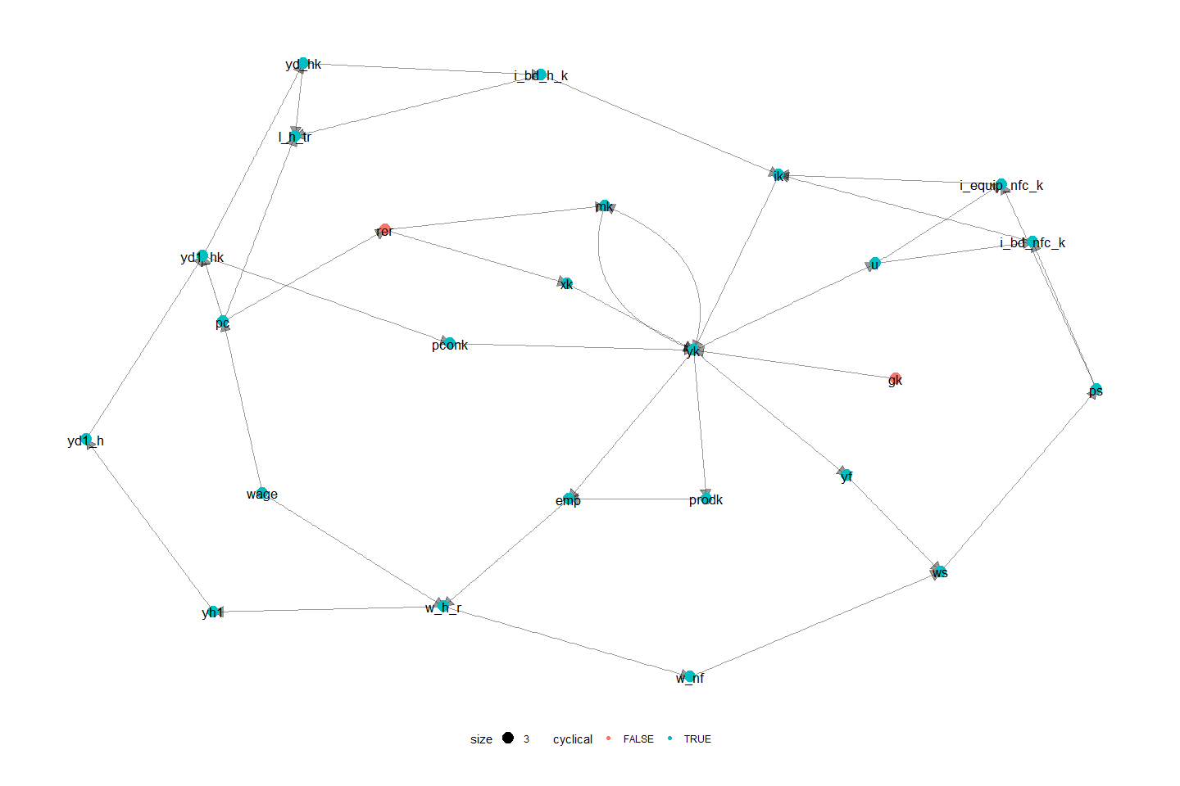

## Appendix 2: Sensitivity analysis

To make sure that the results obtained in this paper, as well as the conclusion derived from these results are not affected by small changes of crucial coefficients in the model. We perform a sensitivity test of the most influential parameters in the shocks.

Figure A2‑1: Sensitivity of the relationship between the maximum level of income insurance, and the average level of income insurance.

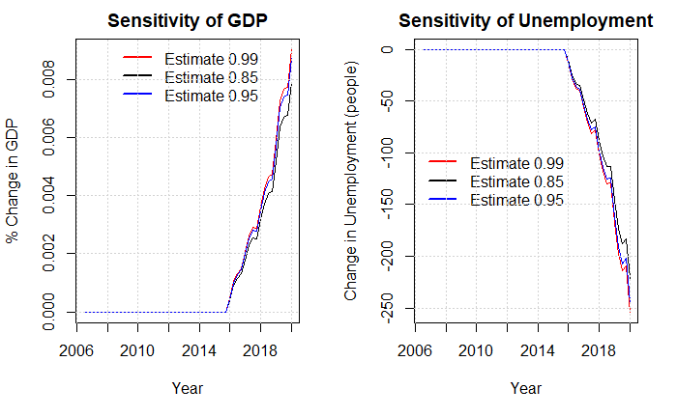

In the plot above we look at the estimate going into the equation of the average income insurance when performing the shock in scenario 1. We know that the estimate should be between 0.85 and 1 as the fraction of receivers of the maximum level of income insurance is 0.85. And no more than 100% can receive the maximum level.

Figure A2‑2: Sensitivity of the minimum wage-gap limit

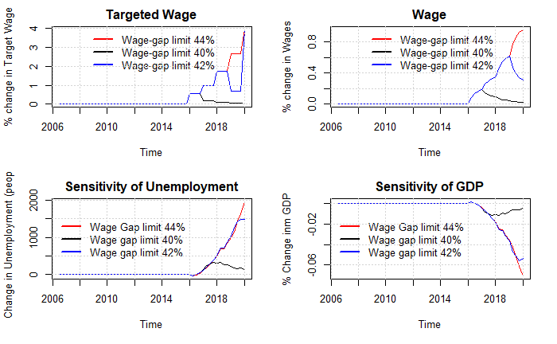

In the plot above we test a central parameter used for the results of this paper being the estimate used for the wage channel setting the limit that the worker unions will allow for the wage gap. As we don’t observe this limit in the data it is hard to find any evidence that backs up the value of this parameter. We use the empirical results from (Fredriksson & Söderström, 2020) setting the minimum wage gap allowed to be 42% of the wage. In the plot below, we see the effects of changing this limit to 40% or 44%.

Figure A1‑3: Relaxing assumptions in the productivity channel

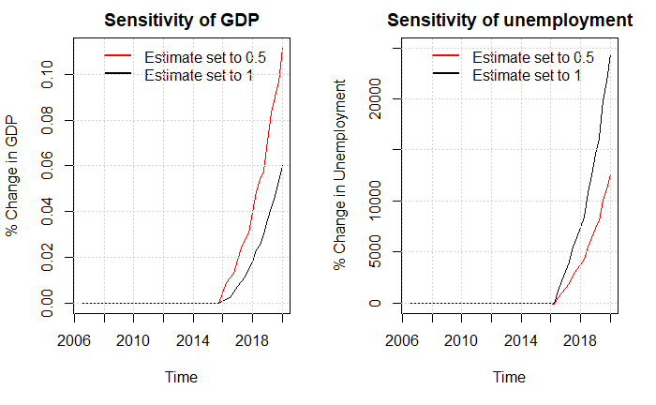

In the figure above we focus on the productivity channel, we mostly exclude this channel due to the lack of empirical justification as well as the radical results found in scenario 5. In an attempt to make the shock more realistic we relax the assumption that firms from one period to another can adjust employment to match the demand, we now obtain much lower effects on unemployment. But the overall match between simulated data and real data is very weak, making these results less trustworthy.

Figure A2‑4: Including the productivity channel in scenario 6.

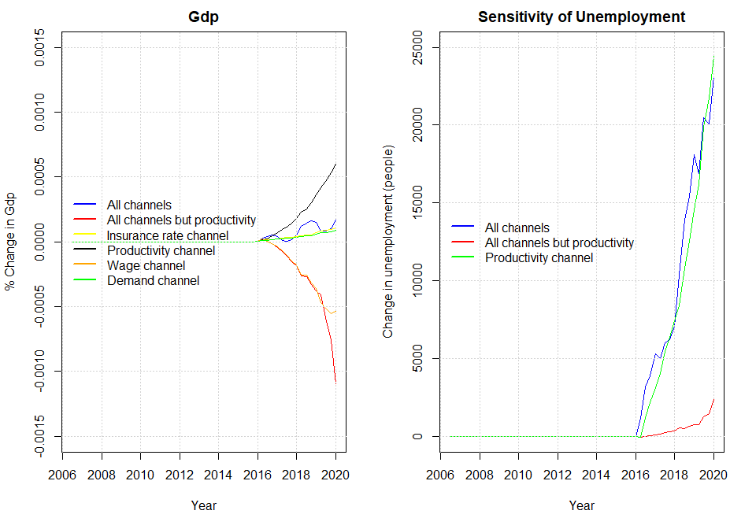

As argued above we exclude the productivity channel in scenario 6 when letting the channels interact. As we mainly use the results from scenario 6 to evaluate the decision to suppress the state regulation percentage, we now show the effects of not excluding the productivity channel when finding these results. As mentioned in the paper, we now obtain an elasticity of 3 of the macroeconomic effects.

Figure A2‑5: Removing autonomous consumption, restricting estimate of the profit-share to -0.1 from -0.45.

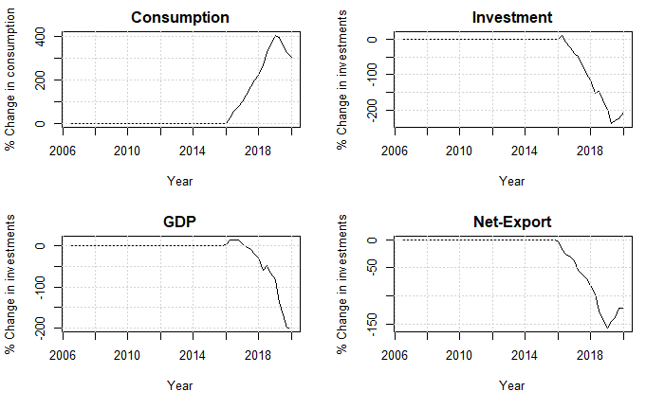

Figure A2-6: Removing autonomous consumption, restricting estimate of the profit-share to 0.1 from 0.45, and setting estimate of real exchange rate on exports to - 0.1 instead of -0.24

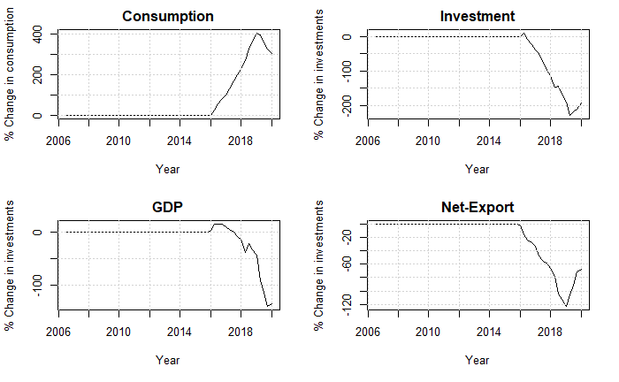

In the two plots above we test the sensitivity of Denmark being categorized as profit led. We do so by changing important coefficients in the investment, consumption and export function. In the last plot we see that the increase in consumption is actually larger than the decrease of investments and net-exports, but as the real government spending is falling (due to nominal government spending being exogenous in the mode) GDP is still decreasing. Here we conclude that really large changes are necessary to define Denmark as wage led.

## Appendix 3: List of equations of the full model and related symbols

As done in the paper, capital letters denote nominal variables and lower-case letters denote real variables.

|  |  |
| --- | --- |
| **Non-Financial Corporations** |  |
|  | (A. 1) |
|  | (A. 2) |
|  | (A. 3) |
|  | (A. 4) |
|  | (A. 5) |
|  | (A. 6) |
|  | (A. 7) |
|  | (A. 8) |
|  | (A. 9) |
|  | (A. 10) |
|  | (A. 11) |
|  | (A. 12) |
|  | (A. 13) |
|  | (A. 14) |
|  | (A. 15) |
|  | (A. 16) |
|  | (A. 17) |
|  | (A. 18) |
|  | (A. 19) |
|  | (A. 20) |
|  | (A. 21) |
|  | (A. 22) |
|  | (A. 23) |
|  | (A. 24) |
|  | (A. 25) |
|  | (A. 26) |
|  | (A. 27) |
|  | (A. 28) |
|  | (A. 29) |
|  | (A. 30) |
|  | (A. 31) |
|  | (A. 32) |
|  | (A. 33) |
|  | (A. 34) |
|  | (A. 35) |
|  | (A. 36) |
|  | (A. 37) |
|  |  |
| **Households** |  |
|  | (A. 38) |
|  | (A. 39) |
|  | (A. 40) |
|  | (A. 41) |
|  | (A. 42) |
|  | (A. 43) |
|  | (A. 44) |
|  | (A. 45) |
|  | (A. 46) |
|  | (A. 47) |
|  |  |
|  | (A. 48) |
|  | (A. 49) |
|  | (A. 50) |
|  | (A. 51) |
|  | (A. 52) |
|  | (A. 53) |
|  | (A. 54) |
|  | (A. 55) |
|  | (A. 56) |
|  | (A. 57) |
|  | (A. 58) |
|  | (A. 59) |
|  | (A. 60) |
|  | (A. 61) |
|  | (A. 62) |
|  | (A. 63) |
|  | (A. 65) |
|  | (A. 66) |
|  | (A. 67) |
|  | (A. 68) |
|  | (A. 69) |
|  | (A. 70) |
|  | (A. 71) |
|  | (A. 72) |
|  | (A. 73) |
|  | (A. 74) |
|  | (A. 75) |
|  | (A. 76) |
|  | (A. 77) |
|  | (A. 78) |
|  | (A. 79) |
|  |  |
| **Financial Sector** |  |
|  | (A. 80) |
|  | (A. 81) |
|  | (A. 82) |
|  | (A. 83) |
|  | (A. 84) |
|  | (A. 85) |
|  | (A. 86) |
|  | (A. 87) |
|  | (A. 88) |
|  | (A. 89) |
|  | (A. 90) |
|  | (A. 91) |
|  | (A. 92) |
|  | (A. 93) |
|  | (A. 94) |
|  | (A. 95) |
|  | (A. 96) |
|  | (A. 97) |
|  | (A. 98) |
|  | (A. 99) |
|  | (A. 100) |
|  | (A. 101) |
|  | (A. 102) |
|  | (A. 103) |
|  |  |
| **Government** |  |
|  | (A. 104) |
|  | (A. 105) |
|  | (A. 106) |
|  | (A. 107) |
|  | (A. 108) |
|  | (A. 109) |
|  | (A. 110) |
|  | (A. 111) |
|  | (A. 112) |
|  | (A. 113) |
|  | (A. 114) |
|  | (A. 115) |
|  | (A. 116) |
|  |  |
| **Rest of the world** |  |
|  | (A. 117) |
|  | (A. 118) |
|  | (A. 119) |
|  | (A. 120) |
|  | (A. 121) |
|  | (A. 122) |
|  | (A. 123) |
|  | (A. 124) |
|  | (A. 125) |
|  | (A. 126) |
|  | (A. 127) |
|  | (A. 128) |
|  | (A. 129) |
|  | (A. 130) |
|  | (A. 131) |
|  | (A. 132) |
|  |  |
| **Labour market** |  |
|  | (A. 133) |
|  | (A. 134) |
|  | (A. 135) |
|  | (A. 136) |
|  | (A. 137) |
|  | (A. 138) |
|  | (A. 139) |
|  | (A. 140) |
|  | (A. 141) |
|  | (A. 142) |
|  | (A. 143) |
|  | (A. 144) |
|  | (A. 145a) |
|  | (A. 146) |
|  | (A. 147) |
|  | (A. 148) |
| **Wage channel equations:** |  |
|  | (A. 145b) |
|  |  |
| **Insurance rate channel equations:** |  |
|  | (A. 149) |
| **Labor-force channel equations:** |  |
|  | (A. 150) |
|  | (A. 151) |
| **Productivity channel equations:** |  |
|  | (A. 152) |

**Symbols**:

N = non-financial corporations, F = financial corporations, G = government, H = Households, W = Rest of the World

|  |  |
| --- | --- |
| Notation | Description |
|  | Nominal GDP |
|  | Nominal Private Consumption |
|  | Nominal Gross fixed capital formation |
|  | Noninal Exports of goods and services |
|  | Nominal Imports of goods and services |
|  | GDP deflator |
|  | Real GDP |
|  | Real Private Consumption |
|  | Real Gross fixed capital formation |
|  | Real Exports of goods and services |
|  | Real Imports of goods and services |
|  | Nonfinancial corporations Nominal Investment in Buildings and Dwellings |
|  | Financial corporations Nominal Investment in Buildings and Dwellings |
|  | Households Nominal Investment in Buildings and Dwellings |
|  | Government Nominal Investment in Buildings and Dwellings |
|  | Nonfinancial corporations Nominal Investment in Equipment |
|  | Financial corporations Nominal Investment in Equipment |
|  | Households Nominal Investment in Equipment |
|  | Government Nominal Investment in Equipment |
|  | Price deflator on consumption |
|  | Wage bill paid by firms |
|  | Wage bill received by households |
|  | Wage bill received by the rest of the world |
|  | Total Employment |
|  | Employment hired to the households |
|  | Employment hired to the rest of the world |
|  | Unemployment |
|  | Rate of unemployment |
|  | Labour force |
|  | Population |
|  | Retired people |
|  | Wage rate |
|  | Disposable income |
|  | Disposable income of profit |
|  | Disposable income on wages/transfers |
|  | Change in pension entitlements |
|  | Benefits received by the households |
|  | Benefits received by the households subtracted the amount paid in income insurance |
|  | Benefits received by the households in the form of income insurance |
|  | Savings |
|  | Aggregate gross operating surplus |
|  | Sectoral gross operating surpluses |
|  | Net interest income on interest bearing assets |
|  | Net interest income on insurance |
|  | Net dividends |
|  | Net indirect taxes |
|  | Income taxes |
|  | Social contributions |
|  | Social benefits |
|  | Other current transfers |
|  | GDP at factor costs |
|  | Profit share |
|  | Labour productivity |
|  | Capacity utilization |
|  | Tobin’s q |
|  | Real exchange rate |
|  | Nominal exchange rate |
|  | Stock of buildings and dwellings |
|  | Stock of capital of equipment |
|  | Net lending |
|  | Current account balance |
|  | Net acquisitions of non-produced non-financial assets |
|  | Capital transfers |
|  | Stock of Equities |
|  | Transaction of equities |
|  | Capital gains on equities |
|  | Nonfinancial corporations’ demand for equities (flow) |
|  | Nonfinancial corporations’ supply of equities (flow) |
|  | Financial corporations’ demand for equities (flow) |
|  | Financial corporations’ supply of equities (flow) |
|  | Households demand for equities issued by nonfinancial corporations |
|  | Households demand for equities issued by financial corporations |
|  | Households demand for equities issued by the rest of the world |
|  | Stock of interest-bearing assets |
|  | Transaction of interest-bearing assets |
|  | Capital gains on interest-bearing assets |
|  | Stock of loans |
|  | Transaction of loans |
|  | Capital gains on loans |
|  | Stock of securities |
|  | Transaction of securities |
|  | Capital gains on securities |
|  | Domestic securities issued by Financial corporations |
|  | Domestic securities held by the rest of the world |
|  | Stock of insurance technical reserves |
|  | Transaction of insurances |
|  | Capital gains on insurances |
|  | Financial net wealth |
|  | Net wealth |
|  | Maximum level of income insurance |
|  | Rate adjustment percentage |
|  | State regulation percentage |
|  | Adjustment percentage |
|  | Compensation rate |
|  | Average amount of income insurance received per person in the IS-program. |
|  | The rate of people being member of the IS-program. |
|  | Inflation |

**Parameters**

|  |  |
| --- | --- |
|  | Net indirect tax rate |
|  | Income tax rate levied Households |
|  | Income tax rate levied on nonfinancial corporations |
|  | Income tax rate levied on financial corporations |
|  | Price deflator of building and dwellings |
|  | Price deflator of Equipment |
|  | Price deflator of imports |
|  | Price deflator of exports |
|  | Price deflator of public consumption |
|  | International price index |
|  | Depreciation rates of the capital stock |
|  | Interest rate on interest-bearing assets |
|  | Interest rate on securities |
|  | Interest rate on loans |
|  | Interest rate on insurance technical reserves |
|  | Dividend distribution rate |
|  | Households share of equities issued by nonfinancial corporations |
|  | Households share of equities issued by financial corporations |
|  | Minimum wage-gap allowed by the workers unions. |

## Appendix 4: estimation of behavioral equations

### Baseline:

Figure A4‑1: Households Consumption

Figure A4‑a: Households investments in buildings and dwellings

Figure A4‑2b: Summary of regression above

Figure A4‑: Benefits received by Households subtracted with the amount paid in income insurance

Figure A4‑: Households demand for loans

Figure A4‑: Households demand for equities

Figure A4‑: Households contribution to the pension system

Figure A4‑: Exports

Figure A4‑: Imports

Figure A4‑a: Non-financial Corporations’ investment in buildings and dwellings

Figure A4‑8b: Summary statistics for regression above

Figure A4‑9a: Non-financial Corporations’ investment in equipment

Figure A4‑9b: Summary statistics for regression above

Figure A4‑10a: Prices

Figure A4‑10b: Summary statistics for regression above

Figure A4‑11: Wages

### Regressions for Scenarios

Figure A4‑12: productivity of workers

Figure A4‑12: Labor force

Figure A4‑13: Insurance rate

1. Theoretically we should look at the reservation salary, but as this is not observable studies usually use different measures of the wage.
2. In the case of Denmark, we would expect this reverse effect to be lower, due to the effects of an active labor policy.
3. Morten Aastrup writes under the organization” Landsorganisationen”, Magnus Jensen and Asbjørn Nørregaard writes under the organization ”Cevea”, and lastly Lizette Risgaard writes under the organization ”Fagbevægelsens Hovedorganisation”
4. The worker insurance started in the 1960s paying 0.9% of the wage, but over time this percentage has increased hitting 12% in 2010, where it has mostly stayed fixed. (Finansministeriet, 2017)
5. Benefits received if you do not meet the requirements of income insurance program.
6. In our opinion this assumption is quite unrealistic, but not many seems to criticize this assumption.
7. If the increase in the maximum level of income insurance is because of an increase in wages, people not at the maximum level of income insurance will still experience an increase as the level of income insurance is calculated based on the higher wages. If the increase in maximum level of income insurance not coming from the wage, it will only increase the income insurance for the 85% receiving the maximum level.
8. The share of people being a member of the income insurance program.
9. We do not see this as a problem, as we are mostly interested in the effects on unemployment.
10. It should be noted that when adding in the macroeconomic channels we create a new baseline for each specific scenario, therefore when performing removing the suppressing of the state regulation rate, the economy can be in different states. Looking at how the baselines fit the current data we do not see this as a major issue in comparing the results of each scenario.
11. In this case the estimate is upward biased, as the shock does not affect the wages, therefore people not receiving the maximum level of income Insurance will not experience an increase. We analyze the effect of this in the sensitivity analysis pg. 51.
12. From the sensitivity analysis pg. 53 it is shown how changes to the minimum wage gap, affects the increase in unemployment. Changing the parameter to 40% unemployment only increases by 121 people, instead setting the parameter to 44% unemployment increases by 2000 people.
13. There does not exist much international evidence for this channel, as in many countries it is required to be part of the income insurance program.
14. Thereby we leave out the two effect mentioned in section 2, that one would expect the ones with the lowest change of unemployment to leave the program first. As well as one would expect the lower insurance rate to reduce the flexibility of firms.
15. The fall in unemployment compared with in scenario 1 is a bit surprising. We reach this result as the increase in the labor-force increases the amount of employed by an even higher magnitude. This may be a result of using a demand -led economy, where the employment is determined out from demand.
16. As mentioned in section 2 Andersen et al. (2015) also finds a reverse effect of income insurance on productivity, in the form of a drop in human capital when the unemployment period increases, this effect should also be captured in the estimate of the average income insurance.
17. In appendix pg. 56 we relax the assumption that firms from one period to another can adjust employment to match the demand, we now obtain much lower effects on unemployment. But the overall match between simulated data and real data is very weak, making these results less trustworthy.
18. Using this result, we calculate the macro elasticity to approximately 3.5, and using the micro elasticity calculated below we get the full macro elasticity to approximately 4. Comparing this with the results of (Fredriksson & Söderström, 2020) who obtain a macro elasticity of 3, we overshoot this a bit. More interesting is the macro elasticity relative to the micro elasticity, where we get the macro elasticity to be eight times as high as the micro elasticity, whereas (Fredriksson & Söderström, 2020) only finds it to be twice as high.
19. The standard set-up of this method is if region 1 is hit by a shock (could be a political decision). We use a region 2 not experiencing the shock to compare with region 1. Thereby using the development in region 2 as a proxy for how the development in region 1 would have continued if not hit by the shock.
20. As we use a dynamic model, we get different estimates of the elasticity for every period. To compare results, we use an average of the elasticity calculated per year. Still there is differences whether we look at the elasticity immediately after the shock in 2016, or the elasticities 4 years after in 2020.
21. When categorizing Denmark to be profit-led as a closed economy we leave out the negative effect of the net exports, which will usually be the determining factor of categorizing open economies as profit-led, instead we only look at the relationship between the increase in consumption relative to the fall in investments when increasing the wage-share.
22. In the appendix pg. 57 we perform a sensitivity analysis finding that even with relatively large changes to the estimates in the consumption, investment, export and import functions the conclusion of Denmark being profit-led stands.
23. One possible critic of this method is that the effects from the income insurance model and the model built in this paper will not interact. We don’t see this affecting the overall results, as it will have no effect on the most dominant channel being the wage channel.
24. Evaluated in 2025, so that the full effects have been carried through.
25. As the participation rate is fixed the fall in employment will directly result in an increase in unemployment of the same amount.
26. In future calculations we will use a value of 0.38
27. As they look at a micro foundation they use the unemployment duration of one person, we will use the amount of unemployed in the economy.
28. As this is the estimated value for 2016, where the suppressing of the state regulation rate started.
29. We use the value of 2016, as this is the year the suppressing of the state regulation percentage started.